

TCET/FRM/IP-02/12 **Term Work Index Sheet**

(To be filled up on regular basis)

Revision: A



| **Sr.**  **No.** | **Name** | **DOP** | **DOC** | **Marks Obtained (100)** | **Signature of Faculty** |
| --- | --- | --- | --- | --- | --- |
|  | **Basic Experiments** |  | | | |
| 1 | Install/configure java development kit(Jdk), android studio,  android sdk |  |  |  |  |
| 2 | Write a program to display hello world on screen. |  |  |  |  |
|  | **Design Experiments / Project / Case Study** |  | | | |
| 3 | Write program to implement frame layout, table layout and  relative layout |  |  |  |  |
| 4 | Write program to implement login window using UI controls. |  |  |  |  |
| 5 | Write a program to implement date and time picker |  |  |  |  |
| 6 | Write a program to implement new activity using explicit intent  and implicit intent |  |  |  |  |
| 7 | Write a program to implement content provider. |  |  |  |  |
| 8 | Write a program to implement database connectivity using  SQLite. |  |  |  |  |
| 9 | Write a program to XML document in android. |  |  |  |  |
| 10 | Write a program to design camera |  |  |  |  |
| 11 | Mini project – Software Engineering Chat interactive quiz app |  |  |  |  |
| 12 |  |  |  |  |  |
|  | **Formative Assessment / Seminar / Remedial work / Assignments** |  | | | |
| 13 | Formative Assessment 1 |  |  |  |  |
| 14 | Formative Assessment 2 |  |  |  |  |
| 15 | Formative Assessment 3 |  |  |  |  |
| 16 |  |  |  |  |  |

DOP – Date of Performance. DOC – Date of Completion

## Certificate

This is to certify that **Student Name** Class Roll no. Course **B.E**. has successfully completed the term work requirements in the Subject **Professional Skills VI** during the academic Year **2022 - 2022**

| Signature of faculty | Signature of HOD | Signature of Dean (Academic) |
| --- | --- | --- |
| Date: | Date: | Date: |

## LAB EVALUATION SHEET

Cycle-1 Roll No.: 46

Experiment/Tutorial No.: 1 - 5

| **Parameters** | **Weig htage** | **Category** | **Performance** | | | | | |
| --- | --- | --- | --- | --- | --- | --- | --- | --- |
| **Excellent (5)** | **Very Good (4)** | **Good (3)** | **Average (2)** | **Below Average**  **(1)** | **Score** |
| Technical Knowledge (Preparedness and Execution) | 30 | Prerequisites (2) |  |  |  |  |  |  |
| Skills in performing experiment (2) |
| Learning (1) |
| Technical Documentation (Developing skills for Journal  Writing and Maintenance of Lab Notebook) | 30 | Format (1) |  |  |  |  |  |  |
| Contents as per Format (2) |
| Quality (2) |
| Level of Interaction (Developing Expression Power) | 10 | Level of Understanding (2) |  |  |  |  |  |  |
| Questions & Answers (2) |
| Application (1) |
| Behavioral  (Attitude Towards Learning) | 10 | Attitude (1) |  |  |  |  |  |  |
| Regularity (2) |
| Team Work / Group Activity(2) |
| Compliance (Attainment of Objectives / Outcomes) | 20 | Course Objective Attainment (3) |  |  |  |  |  |  |
| Learning Objective Attainment (2) |
| **Total** | **100** |  |  |  |  |  |  |  |

Signature of Subject Teacher

## LAB EVALUATION SHEET

Cycle-2 Roll No.: 46

Experiment/Tutorial No.: 6 - 11

| **Parameters** | **Weig htage** | **Category** | **Performance** | | | | | |
| --- | --- | --- | --- | --- | --- | --- | --- | --- |
| **Excellent (5)** | **Very Good (4)** | **Good (3)** | **Average (2)** | **Below**  **Average (1)** | **Score** |
| Technical Knowledge (TK) (Preparedness and Execution) | 30 | Prerequisites (2) |  |  |  |  |  |  |
| Skills in performing experiment (2) |
| Learning (1) |
| Technical Documentation (TD) (Developing skills for Journal Writing and Maintenance of Lab Notebook) | 30 | Format (1) |  |  |  |  |  |  |
| Contents as per Format (2) |
| Quality (2) |
| Level of Interaction (LI) (Developing Expression Power) | 10 | Level of Understanding (2) |  |  |  |  |  |  |
| Questions & Answers (2) |
| Application (1) |
| Behavioral (B)  (Attitude Towards Learning) | 10 | Attitude (1) |  |  |  |  |  |  |
| Regularity (2) |
| Team Work / Group Activity(2) |
| Compliance (C) (Attainment of Objectives / Outcomes) | 20 | Course Objective Attainment (3) |  |  |  |  |  |  |
| Learning Objective Attainment (2) |
| **Total** | **100** |  |  |  |  |  |  |  |

Signature of Subject Teacher

**Evaluation Index Sheet**

| **Sr. No** | **Cycle** | **Expt. No.** | **TK** | **TD** | **LI** | **B** | **C** | **Total** |
| --- | --- | --- | --- | --- | --- | --- | --- | --- |
| 1 | Cycle-1 | 1 – 5 |  |  |  |  |  |  |
| 2 | Cycle-2 | 6 - 11 |  |  |  |  |  |  |
|  | Total |  |  |  |  |  |  |  |
|  | Average |  |  |  |  |  |  |  |

Signature of Subject Teacher



## Experiment 01: Install/ Configure Java Development Kit (JDK), Android Studio, Android SDK and AVD

**Learning Objective:** Student should be able to install java development kit, android studio, android software development kit and android virtual devices.

**Tools:** Android Studio

## Theory:

**Android Studio:**

Android Studio is the official integrated development environment (IDE) for Android application development. It is based on the IntelliJ IDEA, a Java integrated development environment for software, and incorporates its code editing and developer tools. To support application development within the Android operating system, Android Studio uses a Gradle- based build system, emulator, code templates, and GitHub integration. Every project in Android Studio has one or more modalities with source code and resource files. These modalities include Android app modules, Library modules, and Google App Engine modules.

It is an open source software platform and operating system for mobile devices which is based on the Linux kernel. It was developed by Google and later by the Open Handset Alliance (OHA). It allows writing managed code in the Java language and Kotlin language. It has its own virtual machine i.e. DVM (Dalvik Virtual Machine), which is used for executing the android application.

Android is a multi-process system, in which each application (and parts of the system) runs in its own process. Most security between applications and the system is enforced at the process level through standard Linux facilities, such as user and group IDs that are assigned to applications. It uses an Instant Push feature to push code and resource changes to a running application. A code editor assists the developer with writing code and offering code completion, refraction, and analysis. Applications built in Android Studio are then compiled into the APK format for submission to the Google Play Store.

## Java Development Kit:

The Java Development Kit (JDK) is a software development environment that offers a collection of tools and libraries necessary for developing Java applications. One need to the JDK to convert your source code into a format that the Java Runtime Environment (JRE) can execute. The JDK includes the Java Runtime Environment (JRE), an interpreter (java), a compiler (javac), an archiver (jar), a documentation generator (javadoc), and some other development tools. The Java Runtime Environment itself consists of the Java Virtual Machine (JVM), supporting files, and core classes.

## Android Software Development Kit:

Android software development is the process by which applications are created for devices running the Android operating system. The Android SDK is a collection of software development tools and libraries required to develop Android applications. Every time Google releases a new version of Android or an update, a corresponding SDK is also released which developers must download and install. It is worth noting that you can also download and use the Android SDK independently of Android Studio, but typically you'll be working through Android Studio for any Android development. The Android [software development kit](https://en.wikipedia.org/wiki/Software_development_kit) (SDK) includes a comprehensive set of development tools. These include a [debugger](https://en.wikipedia.org/wiki/Debugger), [libraries](https://en.wikipedia.org/wiki/Library_(computing)), a handset [emulator](https://en.wikipedia.org/wiki/Emulator) based on [QEMU](https://en.wikipedia.org/wiki/QEMU), documentation, sample code, and tutorials. These tools provide a smooth flow of the development process from developing and debugging, through to packaging.

## Android Virtual Device:

The Android Emulator simulates Android devices on computer so that one can test their application on a variety of devices and Android API levels without needing to have each physical device. The emulator provides almost all of the capabilities of a real Android device. It can simulate incoming phone calls and text messages, specify the location of the device, simulate different network speeds, simulate rotation and other hardware sensors, access the Google Play Store, and much more. An Android Virtual Device (AVD) is a configuration that defines the characteristics of an Android phone, tablet, Wear OS, Android TV, or Automotive OS device that you want to simulate in the Android Simulator. The AVD Manager is an interface you can launch from Android Studio that helps you create and manage AVDs. An AVD contains a hardware profile, system image, storage area, skin, and other properties.

## Implementation:

Download the android studios from the site.

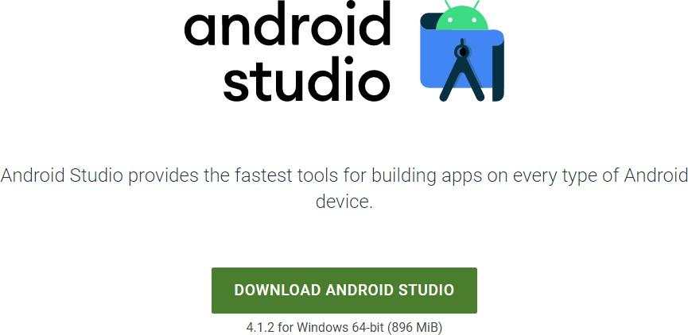

After the downloading has finished, open the file from downloads and run it.

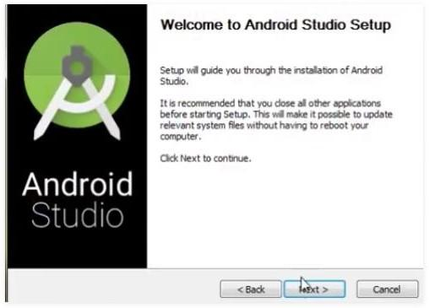

After completing the installation process, the application opened.

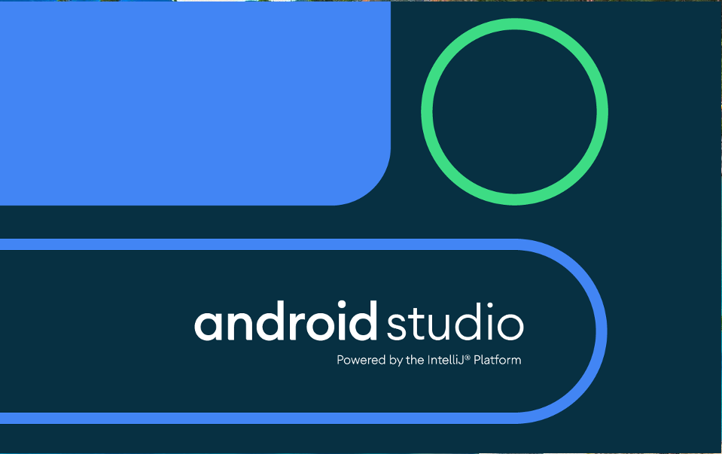

Create a new project

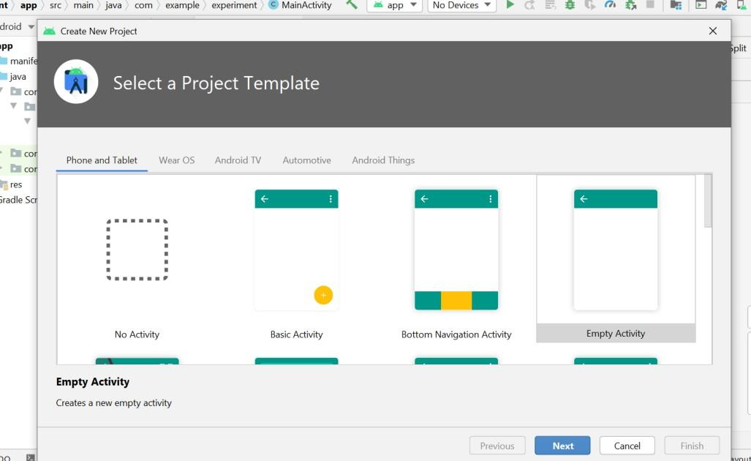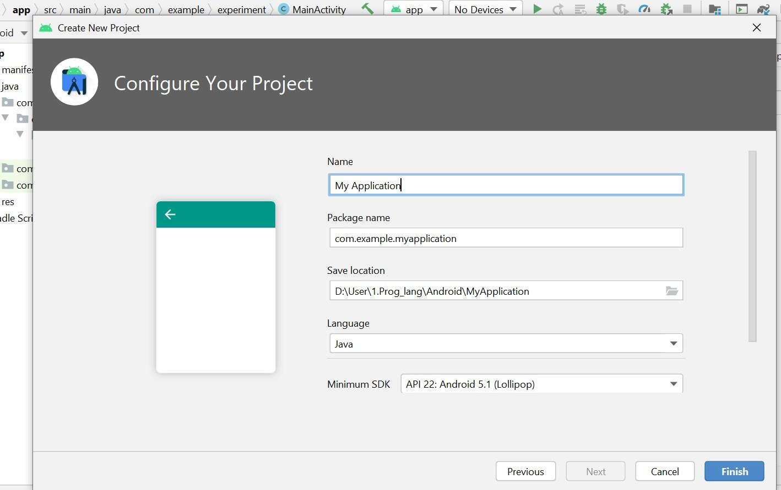

Conclusion:

We learnt in this experiment the theory of android studios, Java development kit, android software development kit and android virtual devices. We also studied that JDK is a development environment that uses the JAVA programming language to create software, applets, and components. Android Studio is an IDE which, using Java Programming, is used for simple and seamless app construction. On any form of Android device, Android Studio offers the quickest tools for developing applications. The Android SDK contains all the tools required for scratching and even checking programs. AVD is used to run Android Studio- developed software, allowing for simpler testing. All the necessities appropriate for construction applications have also been installed.



# Experiment 02: Write a program to display hello world on screen.

**Learning Objective:** Student should be able to write a program to display hello world on screen.

**Tools:** Android Studio

# Theory:

## Android Studio:

Android Studio is the official integrated development environment (IDE) for Android application development. It is based on the IntelliJ IDEA, a Java integrated development environment for software, and incorporates its code editing and developer tools. To support application development within the Android operating system, Android Studio uses a Gradle- based build system, emulator, code templates, and GitHub integration. Every project in Android Studio has one or more modalities with source code and resource files. These modalities include Android app modules, Library modules, and Google App Engine modules.

It is an open source software platform and operating system for mobile devices which is based on the Linux kernel. It was developed by Google and later by the Open Handset Alliance (OHA). It allows writing managed code in the Java language and Kotlin language. It has its own virtual machine i.e. DVM (Dalvik Virtual Machine), which is used for executing the android application. Applications built in Android Studio are then compiled into the APK format for submission to the Google Play Store.

Android apps are built as a combination of components that can be invoked individually. For example, an activity is a type of app component that provides a user interface (UI). The "main" activity starts when the user taps the application's icon. One can also direct the user to an activity from elsewhere, such as from a notification or even from a different app. Other components, such as broadcast receivers and services, allow the application to perform background tasks without a UI.

To navigate transitions between stages of the activity lifecycle, the Activity class provides a core set of six callbacks: onCreate(), onStart(), onResume(), onPause(), onStop(), and onDestroy(). The system invokes each of these call-backs as an activity enters a new state. As the user begins to leave the activity, the system calls methods to dismantle the activity. In some cases, this dismantlement is only partial; the activity still resides in memory (such as when the user switches to another app), and can still come back to the foreground.

# Implementation:

## activity_main.xml

*<?*xml version="1.0" encoding="utf-8"*?>*

<androidx.constraintlayout.widget.ConstraintLayout xmlns:android="[http://schemas.android.com/apk/res/android"](http://schemas.android.com/apk/res/android)

xmlns:app="[http://schemas.android.com/apk/res-auto"](http://schemas.android.com/apk/res-auto) xmlns:tools="[http://schemas.android.com/tools"](http://schemas.android.com/tools) android:layout_width="match_parent" android:layout_height="match_parent" tools:context=".MainActivity">

<TextView android:id="@+id/textView2" android:layout_width="154dp" android:layout_height="109dp"

android:fontFamily="@font/abril_fatface" android:gravity="center" android:text="Hello World!" android:textSize="20sp"

app:layout_constraintBottom_toBottomOf="parent" app:layout_constraintEnd_toEndOf="parent" app:layout_constraintStart_toStartOf="parent" app:layout_constraintTop_toBottomOf="@+id/textView" />

<TextView android:id="@+id/textView" android:layout_width="417dp" android:layout_height="74dp" android:background="#f2f2f2"

android:fontFamily="@font/abril_fatface" android:gravity="center" android:text="Experiment 2" android:textSize="24sp" app:layout_constraintEnd_toEndOf="parent" app:layout_constraintStart_toStartOf="parent" app:layout_constraintTop_toTopOf="parent" />

</androidx.constraintlayout.widget.ConstraintLayout>

## MainActivity.java

package com.example.experiment;

import androidx.appcompat.app.AppCompatActivity; import android.os.Bundle;

public class MainActivity extends AppCompatActivity {

@Override

protected void onCreate(Bundle savedInstanceState) { super.onCreate(savedInstanceState); setContentView(R.layout.activity_main);

}

}

**Design:**

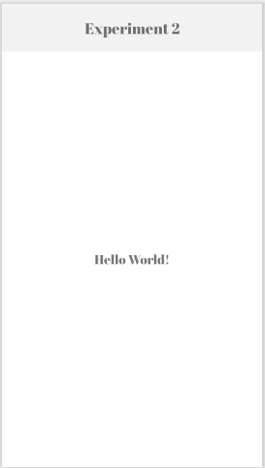

# Conclusion:

We understood in this experiment the concept of android studios and basic lifecycle of application in android studios. We implemented the basic hello world program which includes building an application and running it on Android Virtual Device.



# Experiment 03: Write program to implement frame layout, table layout and relative layout.

**Learning Objective:** Student should be able to write program to implement frame layout, table layout and relative layout.

**Tools:** Android Studio

**Theory:**

## Android Studio:

Android Studio is the official integrated development environment (IDE) for Android application development. It is based on the IntelliJ IDEA, a Java integrated development environment for software, and incorporates its code editing and developer tools. To support application development within the Android operating system, Android Studio uses a Gradle- based build system, emulator, code templates, and GitHub integration. It is an open source software platform and operating system for mobile devices which is based on the Linux kernel. It was developed by Google and later by the Open Handset Alliance (OHA). It allows writing managed code in the Java language and Kotlin language. It has its own virtual machine i.e. DVM (Dalvik Virtual Machine), which is used for executing the android application.

To navigate transitions between stages of the activity lifecycle, the Activity class provides a core set of six callbacks: onCreate(), onStart(), onResume(), onPause(), onStop(), and onDestroy(). The system invokes each of these call-backs as an activity enters a new state. As the user begins to leave the activity, the system calls methods to dismantle the activity.

## Table Layout:

It is a layout that consists of rows and columns. It is further divided as [TableRow](https://developer.android.com/reference/android/widget/TableRow) objects, each defining a row a layout. A layout that arranges its children horizontally. A TableRow should always be used as a child of a [TableLayout.](https://developer.android.com/reference/android/widget/TableLayout) If a TableRow's parent is not a TableLayout, the TableRow will behave as a horizontal [LinearLayout](https://developer.android.com/reference/android/widget/LinearLayout). The children of a TableRow do not need to specify the layout_width and layout_height attributes in the XML file. TableRow always enforces those values to be respectively [View Group.Layout Params](https://developer.android.com/reference/android/view/ViewGroup.LayoutParams#MATCH_PARENT)

[.MATCH_PARENT](https://developer.android.com/reference/android/view/ViewGroup.LayoutParams#MATCH_PARENT) and [View Group . Layout Params. WRAP_CONTENT](https://developer.android.com/reference/android/view/ViewGroup.LayoutParams#WRAP_CONTENT). TableLayout containers do not display border lines for their rows, columns, or cells. Each row has zero or more cells; each cell can hold one [View](https://developer.android.com/reference/android/view/View) object. The table has as many columns as the row with the most cells. A table can leave cells empty. Cells can span columns, as they can in HTML.

## Frame Layout:

It is one of the simplest layout to organize view controls. Frame Layout is designed to block out an area on the screen to display a single item. Generally, FrameLayout should be used to hold a single child view, because it can be difficult to organize child views in a way that's scalable to different screen sizes without the children overlapping each other. We can add multiple children to a FrameLayout and control their position by assigning gravity to each child, using the android:layout_gravity attribute.

## Relative Layout:

RelativeLayout is a view group that displays child views in relative positions. The position of each view can be specified as relative to sibling elements (such as to the left-of or below another view) or in positions relative to the parent RelativeLayout area (such as aligned to the bottom, left or center). It is a very powerful utility for designing a user interface because it can eliminate nested view groups and keep your layout hierarchy flat, which improves performance. If you find yourself using several nested LinearLayout groups, you may be able to replace them with a single RelativeLayout. The Relative Layout is very flexible layout used in android for custom layout designing. It gives us the flexibility to position our component/view based on the relative or sibling component’s position. Just because it allows us to position the component anywhere we want so it is considered as most flexible layout.

**Implementation:**

## activity_main.xml

<?xml version="1.0" encoding="utf-8"?>

<LinearLayout xmlns:android="<http://schemas.android.com/apk/res/android>" xmlns:app="[http://schemas.android.com/apk/res-auto"](http://schemas.android.com/apk/res-auto) android:layout_height="match_parent" android:layout_width="match_parent" android:orientation="vertical"

>

<RelativeLayout android:layout_width="wrap_content" android:layout_height="wrap_content"

>

<ImageView android:id="@+id/header"

android:layout_width="wrap_content" android:layout_height="wrap_content" app:srcCompat="@drawable/comps_header" android:background="@color/white">

</ImageView>

<TextView android:id="@+id/heading"

android:layout_width="match_parent" android:layout_height="40dp" android:fontFamily="@font/playfair_display" android:gravity="center" android:text="STUDENT DETAILS " android:background="#fece2f" android:textColor="@color/white" android:textSize="24sp" android:textStyle="bold" android:layout_below="@id/header"

/>

<TableLayout android:id="@id/table"

android:layout_width="match_parent" android:layout_height="wrap_content" android:layout_below="@id/heading" android:layout_alignParentEnd="true" android:layout_marginTop="0dp" android:layout_marginEnd="0dp" android:background="@color/white"

>

<TableRow android:layout_width="wrap_content" android:layout_height="wrap_content">

<TextView android:layout_width="50dp" android:layout_height="wrap_content" android:layout_column="1"

android:fontFamily="@font/playfair_display" android:gravity="center" android:padding="5dp"

android:text="Sr No." android:textColor="@color/black" android:textSize="14sp" android:textStyle="bold" />

<TextView android:layout_width="130dp" android:layout_height="wrap_content" android:layout_column="1"

android:fontFamily="@font/playfair_display" android:gravity="center" android:padding="5dp"

android:text="Name" android:textColor="@color/black" android:textSize="14sp" android:textStyle="bold" />

<TextView android:layout_width="70dp" android:layout_height="wrap_content" android:layout_column="1"

android:fontFamily="@font/playfair_display" android:textColor="@color/black" android:gravity="center" android:padding="5dp"

android:text="Year" android:textSize="14sp" android:textStyle="bold" />

<TextView android:layout_width="80dp" android:layout_height="wrap_content" android:layout_column="1"

android:fontFamily="@font/playfair_display" android:textColor="@color/black" android:gravity="center" android:padding="5dp" android:text="Branch" android:textSize="14sp" android:textStyle="bold" />

<TextView android:layout_width="64dp" android:layout_height="wrap_content" android:layout_column="1"

android:fontFamily="@font/playfair_display" android:textColor="@color/black" android:gravity="center" android:padding="5dp" android:text="Division" android:textSize="14sp" android:textStyle="bold" />

</TableRow>

<TableRow

android:layout_width="wrap_content" android:layout_height="wrap_content">

<TextView android:layout_width="wrap_content" android:layout_height="wrap_content" android:layout_column="1" android:textColor="@color/black" android:gravity="center" android:padding="5dp" android:text="1." />

<TextView android:layout_width="130dp" android:layout_height="wrap_content" android:layout_column="1"

android:fontFamily="@font/playfair_display" android:textColor="@color/black" android:gravity="center" android:padding="5dp" android:text="Khyaati Shrikant" />

<TextView android:layout_width="70dp" android:layout_height="wrap_content" android:layout_column="1"

android:fontFamily="@font/playfair_display" android:textColor="@color/black" android:gravity="center" android:padding="5dp"

android:text="T.E" />

<TextView android:layout_width="80dp" android:layout_height="wrap_content"

android:layout_column="1" android:fontFamily="@font/playfair_display" android:textColor="@color/black" android:gravity="center" android:padding="5dp" android:text="COMP" />

<TextView android:layout_width="64dp" android:layout_height="wrap_content" android:layout_column="1"

android:fontFamily="@font/playfair_display" android:textColor="@color/black" android:gravity="center" android:padding="5dp"

android:text="A" />

</TableRow>

<TableRow>

<TextView android:layout_width="wrap_content" android:layout_height="wrap_content" android:textColor="@color/black" android:layout_column="1" android:gravity="center" android:padding="5dp" android:text="2." />

<TextView android:layout_width="130dp" android:layout_height="wrap_content" android:layout_column="1"

android:fontFamily="@font/playfair_display" android:textColor="@color/black" android:gravity="center"

android:padding="5dp" android:text="Khyaati " />

<TextView android:layout_width="70dp" android:layout_height="wrap_content" android:layout_column="1"

android:fontFamily="@font/playfair_display" android:textColor="@color/black" android:gravity="center" android:padding="5dp"

android:text="T.E" />

<TextView android:layout_width="80dp" android:layout_height="wrap_content" android:layout_column="1"

android:fontFamily="@font/playfair_display" android:textColor="@color/black" android:gravity="center" android:padding="5dp" android:text="COMP" />

<TextView android:layout_width="64dp" android:layout_height="wrap_content" android:layout_column="1"

android:fontFamily="@font/playfair_display" android:textColor="@color/black" android:gravity="center" android:padding="5dp"

android:text="A" />

</TableRow>

</TableLayout>

</RelativeLayout>

<RelativeLayout android:layout_width="match_parent" android:layout_height="match_parent" android:layout_below="@id/table">

<FrameLayout android:layout_width="match_parent" android:layout_height="match_parent"

>

<ImageView android:id="@+id/frame1"

android:layout_width="match_parent" android:layout_height="360dp" android:background="@color/white" app:srcCompat="@drawable/bookimage"></ImageView>

<TextView android:id="@+id/frame2"

android:layout_width="match_parent" android:layout_height="wrap_content" android:layout_margin="28dp" android:fontFamily="@font/playfair_display" android:padding="10sp" android:text="Notice:

\nIt is a frame layout.

\nAbove is list of TE COMP A students.

\nIn this frame layout, there is an image in the background, text and one clickable button."

android:textColor="@color/white" android:textSize="26dp" android:textStyle="bold" />

<Button

android:id="@+id/close_button" android:layout_width="wrap_content" android:layout_height="wrap_content" android:layout_marginStart="150dp" android:layout_marginTop="310dp" android:backgroundTint="#ffffe0" android:elevation="12dp" android:fontFamily="@font/playfair_display" android:text="CLOSE" android:textColor="@color/black" android:textStyle="bold" app:cornerRadius="8dp" />

</FrameLayout>

</RelativeLayout>

</LinearLayout>

## MainActivity.java

package com.example.experiment;

import androidx.appcompat.app.AppCompatActivity; import android.os.Bundle;

import android.widget.Button; import android.widget.ImageView; import android.widget.TableLayout; import android.widget.TextView;

public class experiment3 extends AppCompatActivity { ImageView comp_header, image ;

TextView stud_heading; TableLayout tableLayout ; Button close;

@Override

protected void onCreate(Bundle savedInstanceState) { super.onCreate(savedInstanceState); setContentView(R.layout.activity_experiment3);

comp_header = findViewById(R.id.header); stud_heading = findViewById(R.id.heading); tableLayout = findViewById(R.id.table); image = findViewById(R.id.frame1);

close = findViewById(R.id.close_button);

}

}

**Design:**

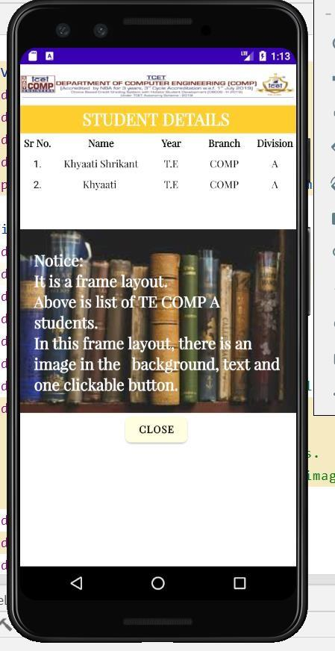

# Conclusion:

We understood in this experiment the concept of basic application layout used in the android studios such as Table layout, Frame layout and Relative layout. We implemented the fundamental program having frame layout, table layout and relative layout and displayed the output on the Android Virtual Device.



# Experiment 04: Write program to implement login window using UI controls.

**Learning Objective:** Student should be able to write a program to implement login window using UI controls.

**Tools:** Android Studio

# Theory:

## Android Studio:

Android Studio is the official integrated development environment (IDE) for Android application development. It is based on the IntelliJ IDEA, a Java integrated development environment for software, and incorporates its code editing and developer tools. Every project in Android Studio has one or more modalities with source code and resource files. These modalities include Android app modules, Library modules, and Google App Engine modules.

The various components used in Android studio are:

1. View: The view is the component which Android Studio provides us to design the layouts of the app. So, we can understand view as a rectangular area which is going to contain some element inside it.
   * TextView: To add some text in your application.
   * EditText: This is used when you want to take some input from the users.
   * ImageView: To add some image in the application.
   * ProgressBar: To show the progress to something. For example, the loading screen.
   * Button: Buttons are used to trigger some action on the click of the button. It can be starting a new activity or something else.
   * ImageButton: It is used to make a clickable image.
   * CheckBox: CheckBox is used to select some options out of many available options.
   * DatePicker: To select some particular date.

Customizations available in a View are Width and Height of a View

1. wrap_content: This will wrap the content of a view. For example, if you are using LinearLayout and the LinearLayout consists of two buttons and you are using the height of the LinearLayout as wrap_content, then the height of the LinearLayout will be equal to the length under which both the buttons are present i.e. the LinearLayout is wrapping the contents present in it.
2. match_parent: If a view is using match_parent, then it will get the same size as its parent is having. For example, if LinearLayout is the parent view and the height of LinearLayout is 80dp, then if we are using Button inside the LinearLayout with height as match_parent, then the height of the Button will also be 80dp i.e. matching the parent.
3. Resources: Resources is folder which contains the images or the layout files or some string values or something else. Following are the folders that are present inside the res folder:
   * Drawable: here, we put all our graphics, vector images, custom drawings.
   * Layout - here, we put all our screen layout files. example: activity_main.xml
   * Mipmap - here, we put the images which are used to make the logo of the application.
   * Values - this folder contains four default files. colors.xml, dimens.xml, strings.xml, style.xml.

# Implementation:

## activity_main.xml

<?xml version="1.0" encoding="utf-8"?>

<LinearLayout xmlns:android="<http://schemas.android.com/apk/res/android>" xmlns:app="<http://schemas.android.com/apk/res-auto>" xmlns:tools="<http://schemas.android.com/tools>" android:layout_width="match_parent" android:layout_height="match_parent"

android:orientation="vertical" android:background="@color/white" tools:context=".userlogin">

<RelativeLayout android:layout_width="match_parent"

android:layout_height="80dp" android:padding="20dp">

<ImageButton android:id="@+id/backButton" android:layout_width="40dp" android:layout_height="40dp" android:cropToPadding="false" app:srcCompat="@drawable/back_icon"/>

<ImageView android:id="@+id/imageView" android:layout_width="wrap_content" android:layout_height="wrap_content" android:layout_marginLeft="40dp" android:layout_marginRight="40dp" app:srcCompat="@drawable/logo" />

<ImageButton android:id="@+id/userButton" android:layout_width="40dp" android:layout_height="40dp" android:cropToPadding="false" app:srcCompat="@drawable/user_new" android:layout_alignParentRight="true"/>

</RelativeLayout>

<androidx.constraintlayout.widget.ConstraintLayout android:layout_width="match_parent" android:layout_height="match_parent">

<ImageView android:layout_width="wrap_content" android:layout_height="0dp" android:src="@drawable/bg_login" app:layout_constraintHeight_percent=".27" android:scaleType="centerCrop" app:layout_constraintVertical_bias="0"

app:layout_constraintBottom_toBottomOf="parent" app:layout_constraintEnd_toEndOf="parent" app:layout_constraintStart_toStartOf="parent"

app:layout_constraintTop_toTopOf="parent"/>

<androidx.constraintlayout.widget.ConstraintLayout android:layout_width="match_parent" android:layout_height="0dp" android:background="@drawable/vie_bg" app:layout_constraintBottom_toBottomOf="parent" app:layout_constraintEnd_toEndOf="parent" app:layout_constraintHeight_percent=".85" app:layout_constraintHorizontal_bias="0.0" app:layout_constraintStart_toStartOf="parent" app:layout_constraintTop_toTopOf="parent" app:layout_constraintVertical_bias="1.0">

<androidx.viewpager.widget.ViewPager android:id="@+id/view_pager" android:layout_width="match_parent" android:layout_height="0dp" app:layout_constraintVertical_bias="0" app:layout_constraintBottom_toBottomOf="parent" app:layout_constraintEnd_toEndOf="parent" app:layout_constraintHeight_percent=".7" app:layout_constraintStart_toStartOf="parent" app:layout_constraintTop_toBottomOf="@+id/tab_layout"/>

<EditText android:id="@+id/email" android:layout_width="0dp"

android:layout_height="wrap_content" android:paddingTop="10dp" android:paddingBottom="10dp" android:paddingStart="20dp" android:hint="Email" android:background="@drawable/text_bg" app:layout_constraintWidth_percent=".8" app:layout_constraintVertical_bias=".25" app:layout_constraintHorizontal_bias=".5"

app:layout_constraintBottom_toBottomOf="parent" app:layout_constraintEnd_toEndOf="parent" app:layout_constraintStart_toStartOf="parent" app:layout_constraintTop_toTopOf="parent"/>

<EditText

android:id="@+id/password" android:layout_width="0dp" android:layout_height="wrap_content" android:hint="Password" android:paddingTop="10dp" android:paddingBottom="10dp" android:paddingStart="20dp" android:layout_marginTop="25dp" android:background="@drawable/text_bg" app:layout_constraintWidth_percent=".8" app:layout_constraintVertical_bias="0" app:layout_constraintHorizontal_bias=".5" app:layout_constraintBottom_toBottomOf="parent" app:layout_constraintEnd_toEndOf="parent" app:layout_constraintTop_toBottomOf="@id/email" app:layout_constraintStart_toStartOf="parent"/>

<TextView android:layout_width="wrap_content" android:layout_height="wrap_content" android:paddingTop="10dp" android:text="Forgot Password ?" android:textSize="18sp"

app:layout_constraintBottom_toBottomOf="parent" app:layout_constraintEnd_toEndOf="parent" app:layout_constraintHorizontal_bias="0.2" app:layout_constraintStart_toStartOf="parent" app:layout_constraintTop_toBottomOf="@id/password" app:layout_constraintVertical_bias="0" app:layout_constraintWidth_percent=".8" />

<Button

android:id="@+id/login_button" android:layout_width="0dp" android:layout_height="60dp" android:fontFamily="@font/playfair_display" android:text="Login" android:textColor="@color/white" android:textSize="20sp" android:textStyle="bold" android:elevation="40dp" app:cornerRadius="15dp" android:backgroundTint="#fece2f"

app:layout_constraintBottom_toBottomOf="parent" app:layout_constraintEnd_toEndOf="parent" app:layout_constraintHorizontal_bias=".5" app:layout_constraintVertical_bias="0.5" app:layout_constraintStart_toStartOf="parent" app:layout_constraintTop_toBottomOf="@id/email"

app:layout_constraintWidth_percent=".8" />

<com.google.android.material.tabs.TabLayout android:id="@+id/tab_layout" android:layout_width="match_parent" android:layout_height="wrap_content" android:background="@drawable/vie_bg" app:layout_constraintBottom_toBottomOf="parent" app:layout_constraintEnd_toEndOf="parent" app:layout_constraintHeight_percent=".9" app:layout_constraintStart_toStartOf="parent" app:layout_constraintTop_toTopOf="parent" app:layout_constraintVertical_bias="0" />

<TextView android:layout_width="wrap_content" android:layout_height="wrap_content" android:text="LOGIN" android:textSize="22sp" android:textStyle="bold" android:fontFamily="@font/playfair_display"

app:layout_constraintBottom_toTopOf="@+id/view_pager" app:layout_constraintEnd_toEndOf="@+id/tab_layout" app:layout_constraintStart_toStartOf="@+id/tab_layout" app:layout_constraintTop_toTopOf="@+id/tab_layout">

</TextView>

<ImageButton android:id="@+id/google_icon" android:layout_width="55dp" android:layout_height="55dp" android:cropToPadding="false" android:background="@drawable/corner" android:elevation="8dp" app:layout_constraintHorizontal_bias="1"

android:layout_marginEnd="30dp" app:layout_constraintBottom_toBottomOf="parent" app:layout_constraintEnd_toStartOf="@+id/fb_icon" app:layout_constraintStart_toStartOf="parent" app:layout_constraintTop_toBottomOf="@+id/view_pager" app:srcCompat="@drawable/google_icon" />

<ImageButton android:id="@+id/fb_icon" android:layout_width="55dp" android:layout_height="55dp" android:cropToPadding="false"

android:background="@drawable/corner" android:elevation="8dp" app:layout_constraintBottom_toBottomOf="parent" app:layout_constraintEnd_toEndOf="@+id/tab_layout" app:layout_constraintStart_toStartOf="parent" app:layout_constraintTop_toBottomOf="@+id/view_pager" app:srcCompat="@drawable/fb_icon" />

<ImageButton android:id="@+id/twitter_icon" android:layout_width="55dp" android:layout_height="55dp" android:cropToPadding="false" android:elevation="8dp" android:background="@drawable/corner" app:layout_constraintHorizontal_bias="0" android:layout_marginStart="30dp"

app:layout_constraintBottom_toBottomOf="parent" app:layout_constraintEnd_toEndOf="@+id/tab_layout" app:layout_constraintStart_toEndOf="@id/fb_icon" app:layout_constraintTop_toBottomOf="@+id/view_pager" app:srcCompat="@drawable/twitter_icon" />

</androidx.constraintlayout.widget.ConstraintLayout>

</androidx.constraintlayout.widget.ConstraintLayout>

</LinearLayout>

## MainActivity.java

package com.example.booknestapplication;

import androidx.appcompat.app.AppCompatActivity; import android.content.Intent;

import android.os.Bundle; import android.view.View;

import android.view.WindowManager; import android.widget.ImageButton;

public class userlogin extends AppCompatActivity { ImageButton backbutton;

@Override

protected void onCreate(Bundle savedInstanceState) { super.onCreate(savedInstanceState);

getWindow().setFlags(WindowManager.LayoutParams.FLAG_FULLSCREEN,WindowManager.LayoutParam s.FLAG_FULLSCREEN);

setContentView(R.layout.activity_userlogin);

backbutton = findViewById(R.id.backButton); backbutton.setOnClickListener(new View.OnClickListener() {

@Override

public void onClick(View v) {

Intent imgButton = new Intent(userlogin.this, dashboard.class); startActivity(imgButton);

}

});

}

}

**Design:**

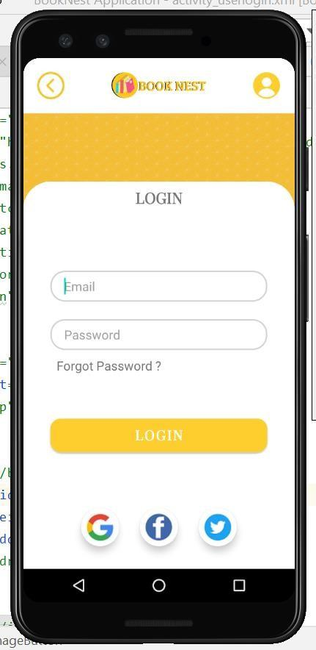

# Conclusion:

We understood in this experiment the various UI components such as EditText, TextView, Button, ImageButton, ImageView and ViewPager, etc. We implemented an appealing user login page.



# Experiment 05: Write a program to implement date and time picker.

**Learning Objective:** Student should be able to write a program to implement date and time picker in Android Studio.

**Tools:** Android Studio

# Theory:

## Android Studio:

Android Studio is the official integrated development environment (IDE) for Android application development. Every project in Android Studio has one or more modalities with source code and resource files. These modalities include Android app modules, Library modules, and Google App Engine modules. It is an open source software platform and operating system for mobile devices which is based on the Linux kernel. It allows writing managed code in the Java language and Kotlin language. Android apps are built as a combination of components that can be invoked individually. For example, an activity is a type of app component that provides a user interface (UI). The "main" activity starts when the user taps the application's icon. One can also direct the user to an activity from elsewhere, such as from a notification or even from a different app. Other components, such as broadcast receivers and services, allow the application to perform background tasks without a UI.

Data and Time Picker:

Android Date Picker allows coder to select the date consisting of day, month and year in the custom user interface. For this functionality android provides DatePicker and DatePickerDialog components.

The DatePickerDialog class consists of a 5 argument constructor with the parameters listed below.

* Context: It requires the application context
* CallBack Function: onDateSet() is invoked when the user sets the date with the following parameters:
* int year : It will be store the current selected year from the dialog
* int monthOfYear : It will be store the current selected month from the dialog
* int dayOfMonth : It will be store the current selected day from the dialog
* int mYear : It shows the the current year that’s visible when the dialog pops up
* int mMonth : It shows the the current month that’s visible when the dialog pops up
* int mDay : It shows the the current day that’s visible when the dialog pops up

The TimePickerDialog class consists of a 5 argument constructor with the parameters listed below.

* Context: It requires the application context
* CallBack Function: onTimeSet() is invoked when the user sets the time with the following parameters:
* int hourOfDay : It will be store the current selected hour of the day from the dialog
* int minute : It will be store the current selected minute from the dialog
* int mHours : It shows the the current Hour that’s visible when the dialog pops up
* int mMinute : It shows the the current minute that’s visible when the dialog pops up
* boolean false : If its set to false it will show the time in 24 hour format else not

# Implementation:

## activity_main.xml

<?xml version="1.0" encoding="utf-8"?>

<LinearLayout xmlns:android="<http://schemas.android.com/apk/res/android>" xmlns:tools="<http://schemas.android.com/tools>" android:layout_width="match_parent" android:layout_height="match_parent"

tools:context=".experiment5" android:orientation="vertical">

<RelativeLayout android:layout_width="match_parent" android:layout_height="wrap_content">

<TextView android:id="@+id/heading"

android:layout_width="match_parent" android:layout_height="50dp" android:layout_alignParentStart="true"

android:background="#ffbb33" android:backgroundTint="@android:color/holo_orange_light" android:fontFamily="@font/abril_fatface"

android:gravity="center" android:text="Student Details" android:textColor="@color/white" android:textSize="25sp" />

</RelativeLayout>

<RelativeLayout android:layout_width="match_parent" android:layout_height="wrap_content">

<TextView android:id="@+id/textnm" android:layout_width="20dp" android:layout_height="40dp"

android:layout_alignParentStart="true" android:layout_alignParentTop="true" android:layout_alignParentEnd="true" android:layout_marginStart="30dp" android:layout_marginTop="50dp" android:layout_marginEnd="250dp" android:fontFamily="@font/playfair_display" android:paddingTop="5dp" android:text="Name: " android:textColor="@color/black" android:textSize="18sp" android:textStyle="bold" />

<EditText android:id="@+id/name"

android:layout_width="wrap_content" android:layout_height="40dp" android:layout_alignParentStart="true" android:layout_alignParentTop="true" android:layout_alignParentEnd="true" android:layout_marginStart="160dp" android:layout_marginTop="50dp" android:layout_marginEnd="54dp" android:ems="10" android:inputType="textPersonName" android:text="Enter your Name" />

<TextView android:id="@+id/textyear" android:layout_width="20dp"

android:layout_height="wrap_content" android:layout_alignParentStart="true" android:layout_alignParentTop="true" android:layout_alignParentEnd="true" android:layout_marginStart="30dp" android:layout_marginTop="110dp" android:layout_marginEnd="250dp" android:fontFamily="@font/playfair_display" android:paddingTop="8dp" android:text="Surname: " android:textColor="@color/black"

android:textSize="18sp" android:textStyle="bold" />

<EditText android:id="@+id/year"

android:layout_width="wrap_content" android:layout_height="40dp" android:layout_alignParentStart="true" android:layout_alignParentTop="true" android:layout_alignParentEnd="true" android:layout_marginStart="160dp" android:layout_marginTop="110dp" android:layout_marginEnd="54dp" android:ems="10" android:inputType="textPersonName" android:text="Enter surname" />

<TextView android:id="@+id/textBranch" android:layout_width="20dp" android:layout_height="wrap_content" android:layout_alignParentStart="true" android:layout_alignParentTop="true" android:layout_alignParentEnd="true" android:layout_marginStart="30dp" android:layout_marginTop="180dp" android:layout_marginEnd="250dp"

android:fontFamily="@font/playfair_display" android:paddingTop="8dp" android:text="Age: " android:textColor="@color/black" android:textSize="18sp" android:textStyle="bold" />

<EditText android:id="@+id/branch"

android:layout_width="wrap_content" android:layout_height="40dp" android:layout_alignParentStart="true" android:layout_alignParentTop="true" android:layout_alignParentEnd="true" android:layout_marginStart="160dp" android:layout_marginTop="180dp" android:layout_marginEnd="54dp" android:ems="10" android:inputType="textPersonName" android:text="Enter age" />

<TextView android:id="@+id/textDiv" android:layout_width="20dp"

android:layout_height="wrap_content" android:layout_alignParentStart="true" android:layout_alignParentTop="true" android:layout_alignParentEnd="true" android:layout_marginStart="30dp"

android:layout_marginTop="250dp" android:layout_marginEnd="250dp" android:fontFamily="@font/playfair_display" android:paddingTop="8dp" android:text="Branch: " android:textColor="@color/black" android:textSize="18sp" android:textStyle="bold" />

<EditText android:id="@+id/division"

android:layout_width="wrap_content" android:layout_height="40dp" android:layout_alignParentStart="true" android:layout_alignParentTop="true" android:layout_alignParentEnd="true" android:layout_marginStart="160dp" android:layout_marginTop="250dp" android:layout_marginEnd="54dp" android:ems="10" android:inputType="textPersonName" android:text="Enter branch " />

<TextView android:id="@+id/texts_id" android:layout_width="20dp"

android:layout_height="wrap_content" android:layout_alignParentStart="true" android:layout_alignParentTop="true" android:layout_alignParentEnd="true" android:layout_marginStart="30dp" android:layout_marginTop="320dp" android:layout_marginEnd="250dp" android:fontFamily="@font/playfair_display" android:paddingTop="8dp" android:text="Roll number: " android:textColor="@color/black" android:textSize="18sp" android:textStyle="bold" />

<EditText android:id="@+id/s_id"

android:layout_width="wrap_content" android:layout_height="40dp" android:layout_alignParentStart="true" android:layout_alignParentTop="true" android:layout_alignParentEnd="true" android:layout_marginStart="160dp" android:layout_marginTop="320dp" android:layout_marginEnd="54dp" android:ems="10" android:inputType="textPersonName" android:text="Enter rollnumber" />

<TextView android:id="@+id/dob"

android:layout_width="20dp" android:layout_height="wrap_content" android:layout_alignParentStart="true" android:layout_alignParentTop="true" android:layout_alignParentEnd="true" android:layout_marginStart="30dp" android:layout_marginTop="380dp" android:layout_marginEnd="250dp" android:fontFamily="@font/playfair_display" android:paddingTop="8dp" android:text="Date of Birth: " android:textColor="@color/black" android:textSize="18sp" android:textStyle="bold" />

<EditText android:id="@+id/dob_text"

android:layout_width="wrap_content" android:layout_height="40dp" android:layout_alignParentStart="true" android:layout_alignParentTop="true" android:layout_alignParentEnd="true" android:layout_marginStart="160dp" android:layout_marginTop="380dp" android:layout_marginEnd="54dp" android:ems="10" android:inputType="textPersonName" android:text="Enter DOB"

/>

<Button

android:id="@+id/dob_button" android:layout_width="136dp" android:layout_height="wrap_content" android:layout_alignParentStart="true" android:layout_alignParentTop="true" android:layout_alignParentEnd="true" android:layout_marginStart="160dp" android:layout_marginTop="430dp" android:layout_marginEnd="54dp" android:backgroundTint="#fece2f" android:elevation="12dp" android:fontFamily="@font/playfair_display" android:text="SET DOB" android:textStyle="bold" />

<TextView android:id="@+id/time" android:layout_width="20dp"

android:layout_height="wrap_content" android:layout_alignParentStart="true" android:layout_alignParentTop="true" android:layout_alignParentEnd="true" android:layout_marginStart="30dp" android:layout_marginTop="500dp" android:layout_marginEnd="250dp"

android:fontFamily="@font/playfair_display" android:paddingTop="8dp" android:text="Select time slot: " android:textColor="@color/black" android:textSize="18sp" android:textStyle="bold" />

<EditText android:id="@+id/time_text"

android:layout_width="wrap_content" android:layout_height="40dp" android:layout_alignParentStart="true" android:layout_alignParentTop="true" android:layout_alignParentEnd="true" android:layout_marginStart="160dp" android:layout_marginTop="500dp" android:layout_marginEnd="54dp" android:ems="10" android:inputType="textPersonName" android:text="Enter Time"

/>

<Button

android:id="@+id/time_button" android:layout_width="136dp" android:layout_height="wrap_content" android:layout_alignParentStart="true" android:layout_alignParentTop="true" android:layout_alignParentEnd="true" android:layout_marginStart="160dp" android:layout_marginTop="550dp" android:layout_marginEnd="54dp" android:backgroundTint="#fece2f" android:elevation="12dp" android:fontFamily="@font/playfair_display" android:text="SET TIME" android:textStyle="bold" />

</RelativeLayout>

</LinearLayout>

## MainActivity.java

package com.example.experiment;

import androidx.appcompat.app.AppCompatActivity; import android.app.DatePickerDialog;

import android.app.TimePickerDialog; import android.os.Bundle;

import android.view.View;

import android.view.WindowManager; import android.widget.Button;

import android.widget.DatePicker; import android.widget.EditText; import android.widget.TimePicker; import java.util.Calendar;

public class experiment5 extends AppCompatActivity {

Button btnDatePicker, btnTimePicker; EditText txtDate, txtTime;

private int mYear, mMonth, mDay, mHour, mMinute;

@Override

protected void onCreate(Bundle savedInstanceState) { super.onCreate(savedInstanceState); getWindow().setFlags(WindowManager.LayoutParams.FLAG_FULLSCREEN,

WindowManager.LayoutParams.FLAG_FULLSCREEN); setContentView(R.layout.activity_experiment5);

txtDate = findViewById(R.id.dob_text); txtTime = findViewById(R.id.time_text);

btnDatePicker = findViewById(R.id.dob_button); btnDatePicker.setOnClickListener(new View.OnClickListener() {

@Override

public void onClick(View v) {

// Get Current Date

final Calendar c = Calendar.getInstance(); mYear = c.get(Calendar.YEAR); mMonth = c.get(Calendar.MONTH);

mDay = c.get(Calendar.DAY_OF_MONTH);

DatePickerDialog datePickerDialog = new DatePickerDialog(experiment5.this, new DatePickerDialog.OnDateSetListener() {

@Override

public void onDateSet(DatePicker view, int year, int monthOfYear, int dayOfMonth) {

txtDate.setText(dayOfMonth + "-" + (monthOfYear + 1) + "-" + year);

}

}, mYear, mMonth, mDay); datePickerDialog.show();

}

});

btnTimePicker = findViewById(R.id.time_button); btnTimePicker.setOnClickListener(new View.OnClickListener() {

@Override

public void onClick(View v) {

// Get Current Time

final Calendar c = Calendar.getInstance(); mHour = c.get(Calendar.HOUR_OF_DAY); mMinute = c.get(Calendar.MINUTE);

// Launch Time Picker Dialog

TimePickerDialog timePickerDialog = new TimePickerDialog(experiment5.this, new TimePickerDialog.OnTimeSetListener() {

@Override

public void onTimeSet(TimePicker view, int hourOfDay, int minute) {

txtTime.setText(hourOfDay + ":" + minute);

}

}

});

}

}

}, mHour, mMinute, false); timePickerDialog.show();

**Design:**

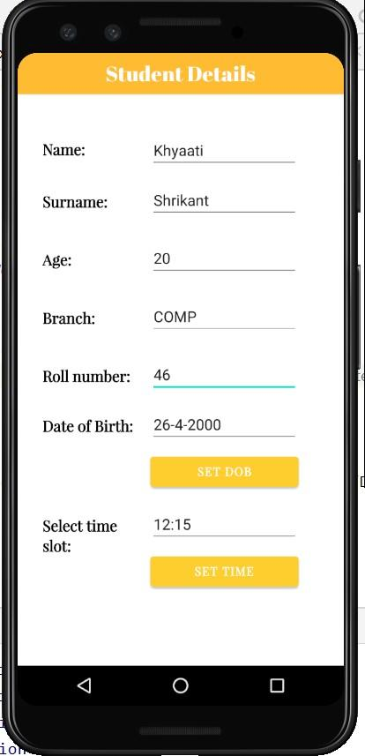

# Conclusion:

We understood in this experiment the concept of date and time picker in android studios. Furthermore the DatePickerDialog class and TimePickerDialog class along with their respective parameters were understood. We implemented program that allows user to pick their date of birth and select a particular time slot. The program was executed on the Android Virtual Device.



## Experiment 06: Write a program to implement new activity using explicit intent and implicit intent.

**Learning Objective:** Student should be able to write a program to implement new activity using explicit intent and implicit intent in Android Studio.

**Tools:** Android Studio

## Theory:

**Android Studio:**

Android Studio is the official integrated development environment (IDE) for Android application development. Every project in Android Studio has one or more modalities with source code and resource files. These modalities include Android app modules, Library modules, and Google App Engine modules. It is an open source software platform and operating system for mobile devices which is based on the Linux kernel. It allows writing managed code in the Java language and Kotlin language. Android apps are built as a combination of components that can be invoked individually. For example, an activity is a type of app component that provides a user interface (UI). The "main" activity starts when the user taps the application's icon. One can also direct the user to an activity from elsewhere, such as from a notification or even from a different app. Other components, such as broadcast receivers and services, allow the application to perform background tasks without a UI.

Intent is an messaging object which passes between components like services, content providers, activities etc. Normally startActivity() method is used for invoking any activity.

Intent Classification

There are two types of intents

1. Implicit Intent
2. Explicit Intent

## Implicit Intent:

Using implicit Intent, component can't be specifying. An action to be performed is declared by implicit intent. Then android operating system will filter out component which will response to the action.

## Explicit Intent:

Using explicit intent any other component can be specified. In other words, the targeted component is specified by explicit intent. So only the specified target component will be invoked.

## Implementation:

**activity_main.xml**

<?xml version="1.0" encoding="utf-8"?>

<LinearLayout xmlns:android="[http://schemas.android.com/apk/res/android"](http://schemas.android.com/apk/res/android) xmlns:tools="[http://schemas.android.com/tools"](http://schemas.android.com/tools) android:layout_width="match_parent" android:layout_height="match_parent"

tools:context=".experiment6" android:orientation="vertical">

<RelativeLayout android:layout_width="match_parent" android:layout_height="wrap_content">

<TextView android:id="@+id/heading"

android:layout_width="match_parent" android:layout_height="50dp" android:layout_alignParentStart="true"

android:background="#ffbb33" android:backgroundTint="@android:color/holo_orange_light" android:fontFamily="@font/abril_fatface" android:gravity="center"

android:text="Experiment 6"

android:textColor="@color/white" android:textSize="25sp" />

</RelativeLayout>

<RelativeLayout android:layout_width="match_parent" android:layout_height="wrap_content">

<TextView android:id="@+id/maintext"

android:layout_width="wrap_content" android:layout_height="40dp" android:layout_alignParentStart="true" android:layout_alignParentTop="true" android:layout_alignParentEnd="true" android:layout_marginStart="70dp" android:layout_marginTop="50dp" android:layout_centerInParent="true" android:fontFamily="@font/alice" android:paddingTop="5dp"

android:text="This is the second page - 46 TE A" android:textColor="@color/black" android:textSize="18sp" android:textStyle="bold" />

<TextView android:id="@+id/textnm" android:layout_width="20dp" android:layout_height="40dp"

android:layout_alignParentStart="true" android:layout_alignParentTop="true" android:layout_alignParentEnd="true" android:layout_marginStart="30dp" android:layout_marginTop="130dp" android:layout_marginEnd="250dp"

android:fontFamily="@font/playfair_display" android:paddingTop="5dp" android:text="Name: " android:textColor="@color/black" android:textSize="18sp" android:textStyle="bold" />

<EditText android:id="@+id/name"

android:layout_width="wrap_content" android:layout_height="40dp" android:layout_alignParentStart="true" android:layout_alignParentTop="true" android:layout_alignParentEnd="true" android:layout_marginStart="160dp" android:layout_marginTop="130dp" android:layout_marginEnd="54dp" android:ems="10" android:inputType="textPersonName" android:text="Enter your Name" />

<TextView android:id="@+id/textyear" android:layout_width="20dp"

android:layout_height="wrap_content" android:layout_alignParentStart="true" android:layout_alignParentTop="true" android:layout_alignParentEnd="true" android:layout_marginStart="30dp" android:layout_marginTop="180dp" android:layout_marginEnd="250dp" android:fontFamily="@font/playfair_display" android:paddingTop="8dp" android:text="Surname: " android:textColor="@color/black" android:textSize="18sp"

android:textStyle="bold" />

<EditText android:id="@+id/year"

android:layout_width="wrap_content" android:layout_height="40dp" android:layout_alignParentStart="true" android:layout_alignParentTop="true" android:layout_alignParentEnd="true" android:layout_marginStart="160dp" android:layout_marginTop="180dp" android:layout_marginEnd="54dp" android:ems="10" android:inputType="textPersonName" android:text="Enter surname" />

<TextView android:id="@+id/textBranch" android:layout_width="20dp" android:layout_height="wrap_content" android:layout_alignParentStart="true" android:layout_alignParentTop="true" android:layout_alignParentEnd="true" android:layout_marginStart="30dp" android:layout_marginTop="230dp" android:layout_marginEnd="250dp"

android:fontFamily="@font/playfair_display" android:paddingTop="8dp" android:text="Branch: " android:textColor="@color/black" android:textSize="18sp" android:textStyle="bold" />

<EditText android:id="@+id/branch"

android:layout_width="wrap_content" android:layout_height="40dp" android:layout_alignParentStart="true" android:layout_alignParentTop="true" android:layout_alignParentEnd="true" android:layout_marginStart="160dp" android:layout_marginTop="230dp" android:layout_marginEnd="54dp" android:ems="10" android:inputType="textPersonName" android:text="Enter branch" />

<TextView android:id="@+id/texts_id" android:layout_width="20dp"

android:layout_height="wrap_content" android:layout_alignParentStart="true" android:layout_alignParentTop="true" android:layout_alignParentEnd="true" android:layout_marginStart="30dp" android:layout_marginTop="280dp" android:layout_marginEnd="250dp" android:fontFamily="@font/playfair_display" android:paddingTop="8dp" android:text="Roll number: " android:textColor="@color/black" android:textSize="18sp" android:textStyle="bold" />

<EditText android:id="@+id/s_id"

android:layout_width="wrap_content" android:layout_height="40dp" android:layout_alignParentStart="true" android:layout_alignParentTop="true" android:layout_alignParentEnd="true"

android:layout_marginStart="160dp" android:layout_marginTop="280dp" android:layout_marginEnd="54dp" android:ems="10" android:inputType="textPersonName" android:text="Enter rollnumber" />

<Button

android:id="@+id/second_button" android:layout_width="136dp" android:layout_height="wrap_content" android:layout_alignParentStart="true" android:layout_alignParentTop="true" android:layout_alignParentEnd="true" android:layout_marginStart="160dp" android:layout_marginTop="350dp" android:layout_marginEnd="54dp" android:backgroundTint="#fece2f" android:elevation="12dp" android:fontFamily="@font/playfair_display" android:text="Second page" android:textStyle="bold" />

</RelativeLayout>

</LinearLayout>

## MainActivity.java

package com.example.experiment;

import androidx.appcompat.app.AppCompatActivity;

import android.content.Intent; import android.os.Bundle;

import android.view.View;

import android.view.WindowManager; import android.widget.Button;

public class experiment6 extends AppCompatActivity { Button btn;

@Override

protected void onCreate(Bundle savedInstanceState) { super.onCreate(savedInstanceState);

getWindow().setFlags(WindowManager.LayoutParams.FLAG_FULLSCREEN, WindowManager.LayoutParams.FLAG_FULLSCREEN);

setContentView(R.layout.activity_experiment6);

btn = findViewById(R.id.second_button); btn.setOnClickListener(new View.OnClickListener() {

@Override

public void onClick(View v) {

Intent send = new Intent(experiment6.this, MainActivity.class); startActivity(send);

}

});

}

}



## Design:

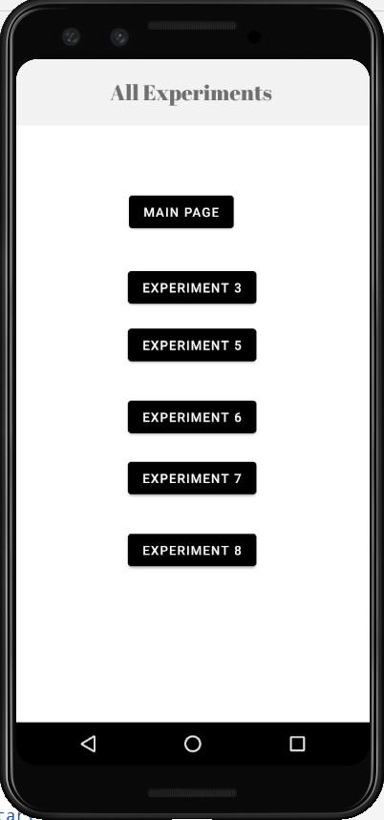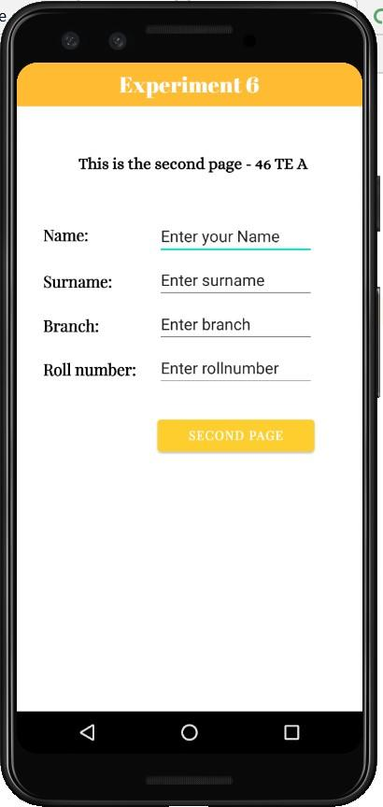

**Conclusion:** We understood in this experiment the concept of intent and types of intent in android studios. We implemented program that implements intent and this was executed on the Android Virtual Device.



## Experiment 07: Write a program to implement content provider.

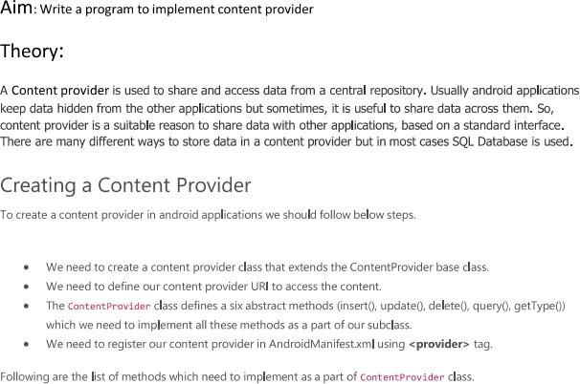

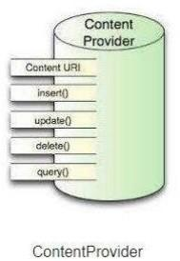

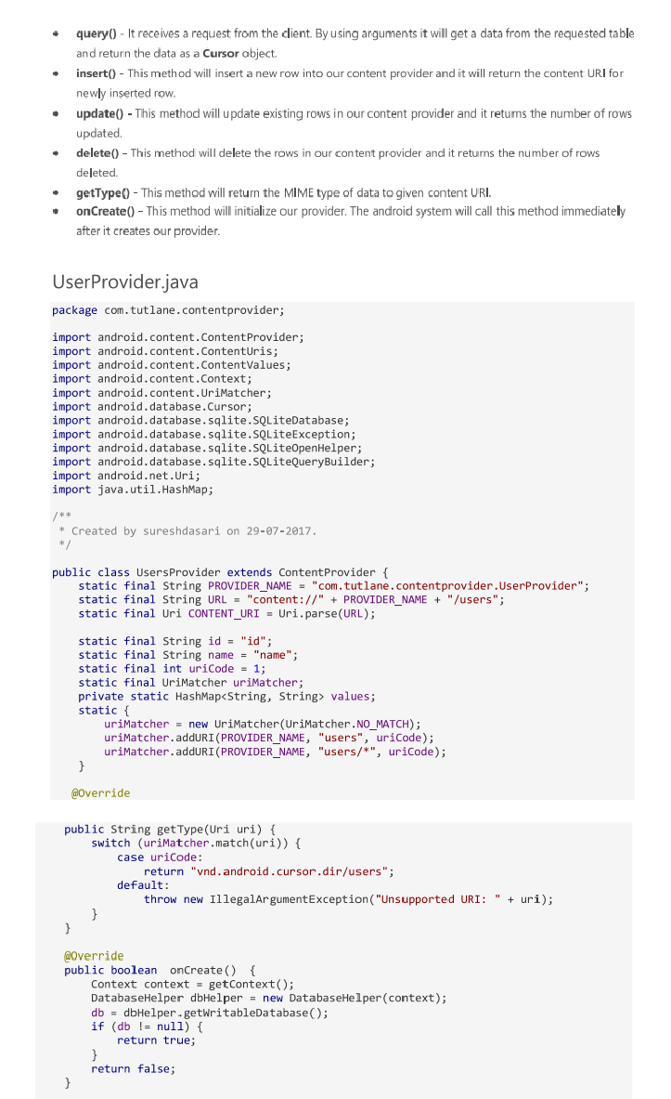

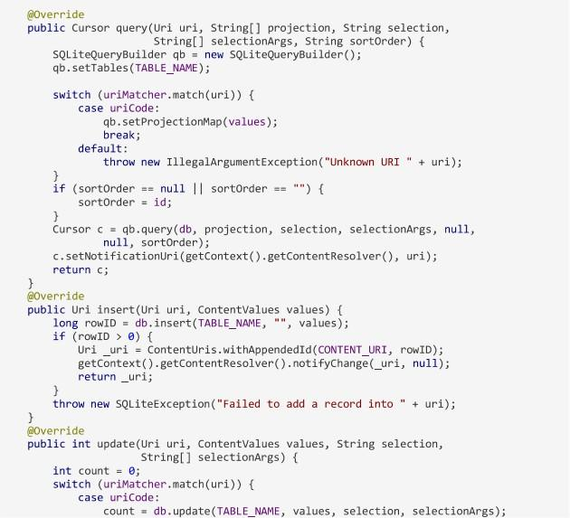

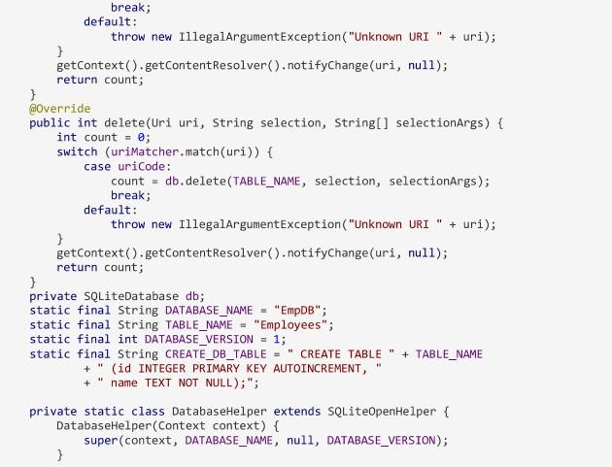

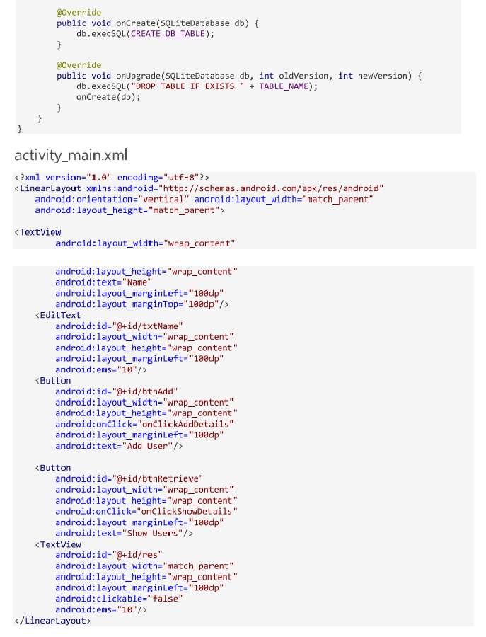

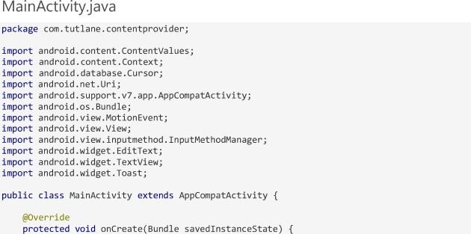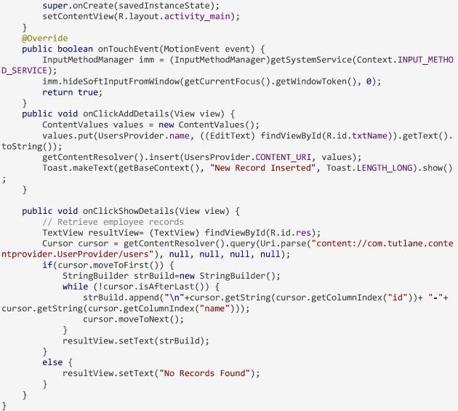

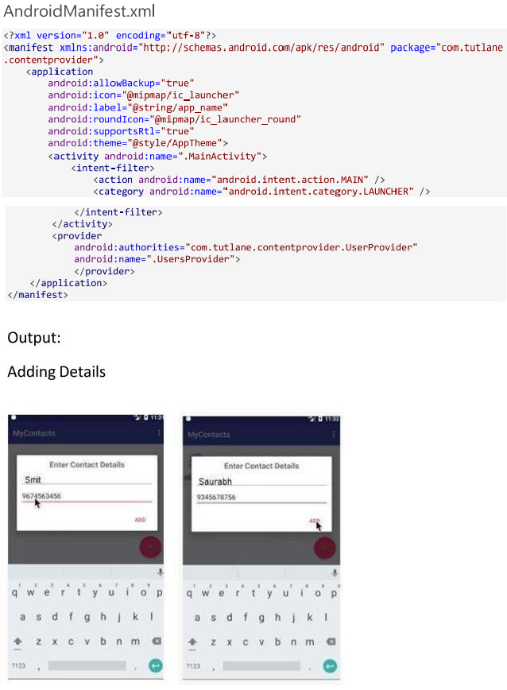

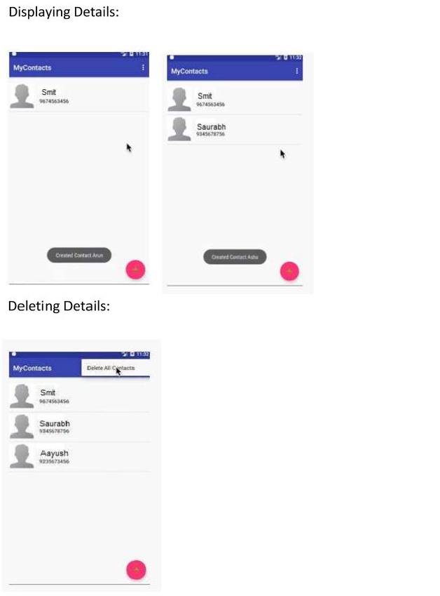



**Experiment 08: Write a program to implement database connectivity using SQLite.**

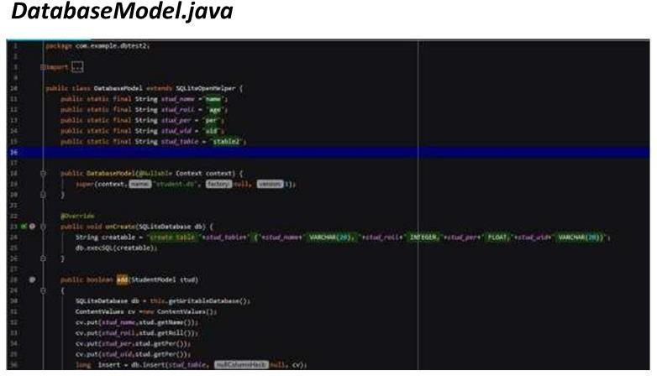

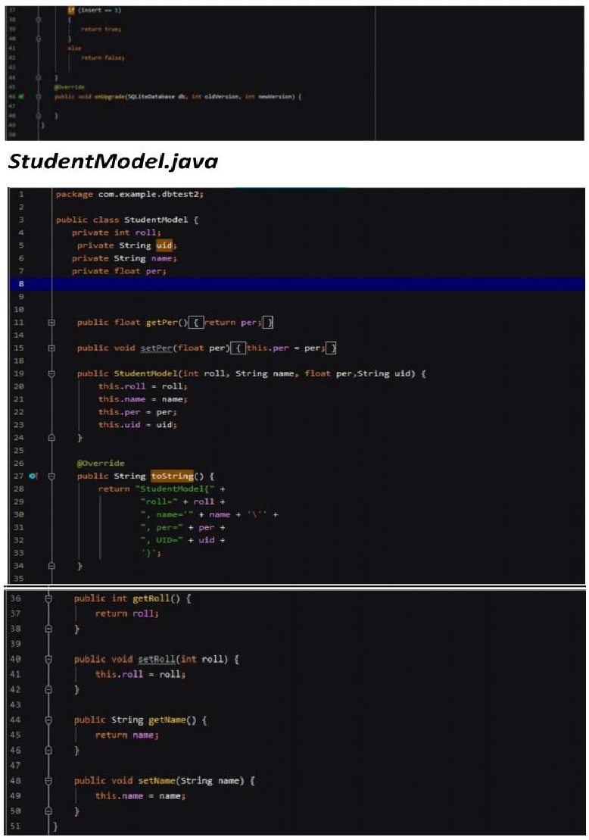

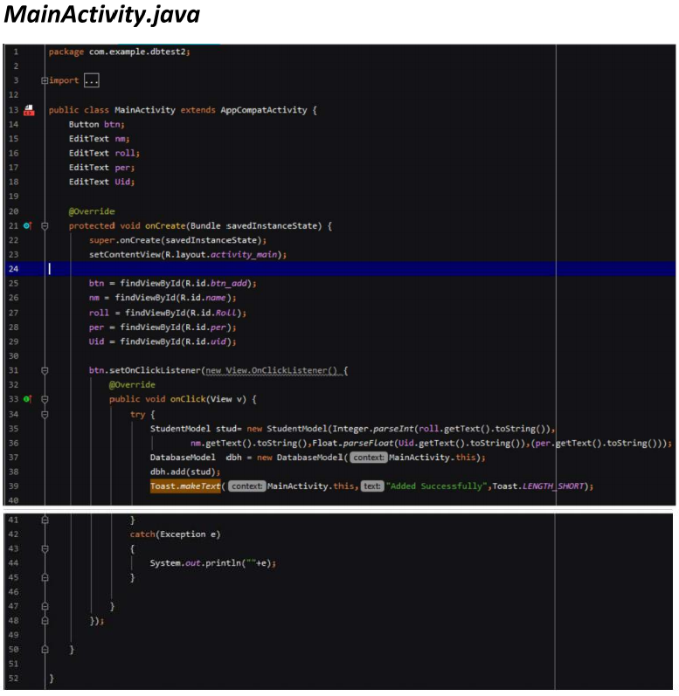

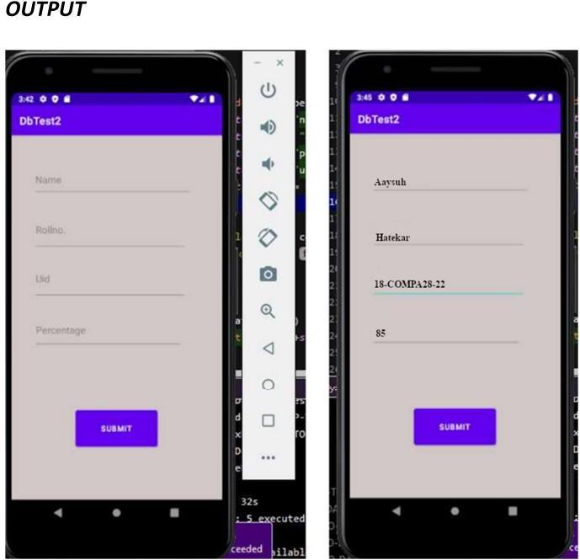

## Conclusion:

We were able to understand and learn database connectivity using SQLite in Android development and implemented successfully.



## Experiment 09: Write a program to implement XML document in android.

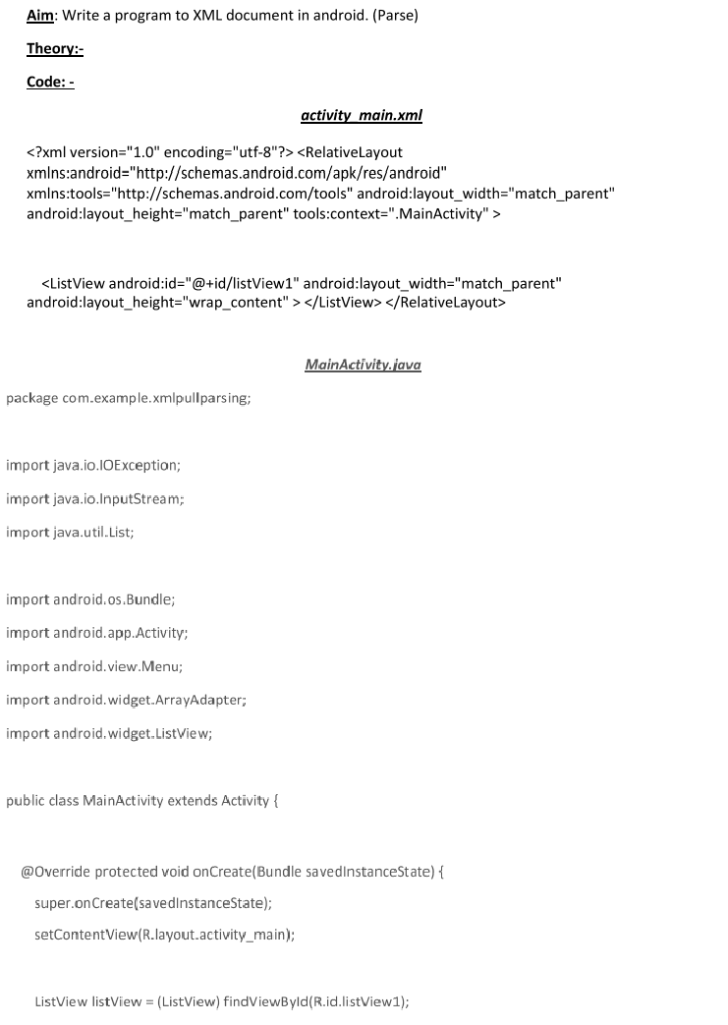

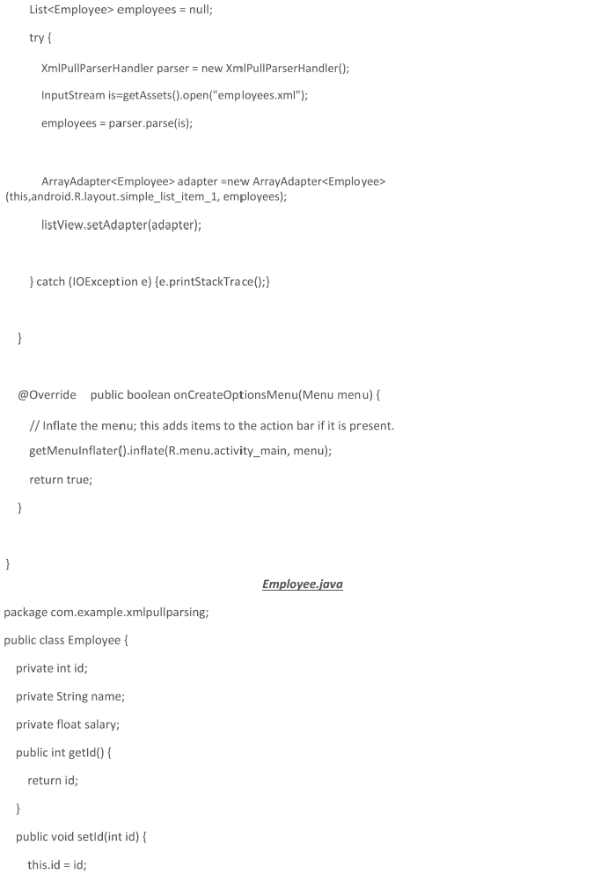

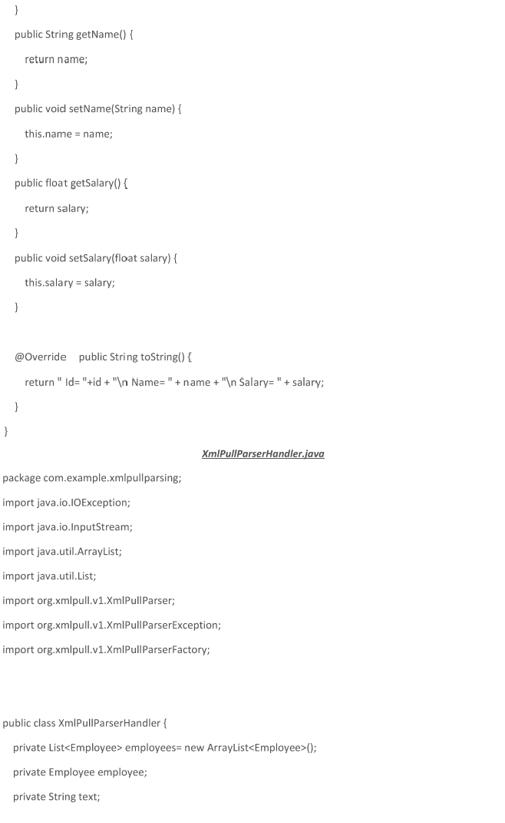

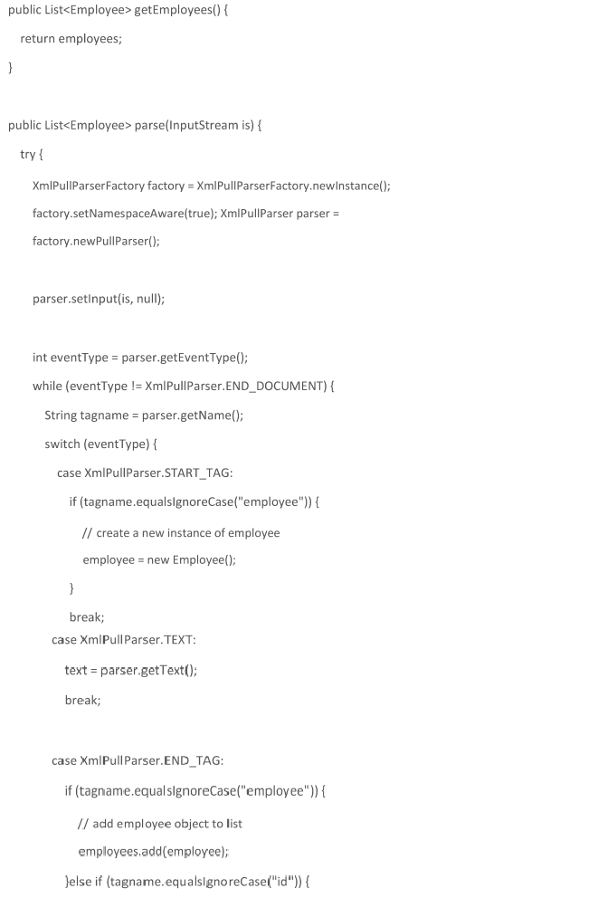

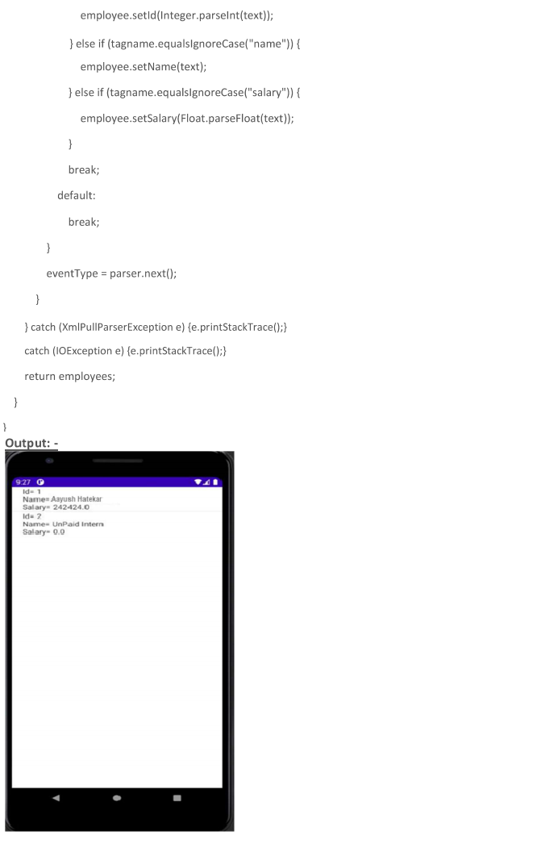



**Experiment 10: Write a program to implement camera.**

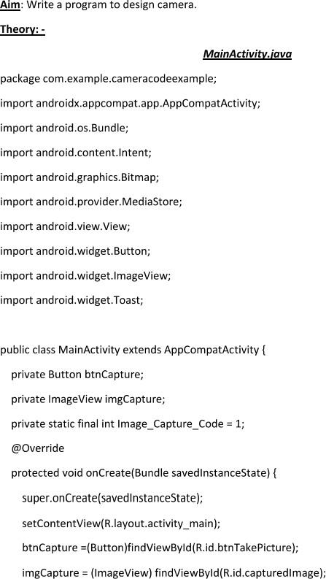

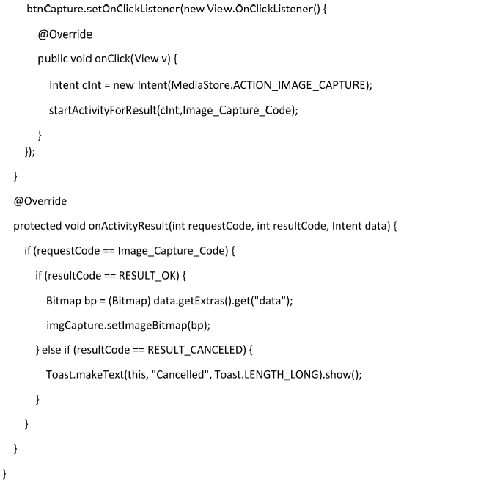

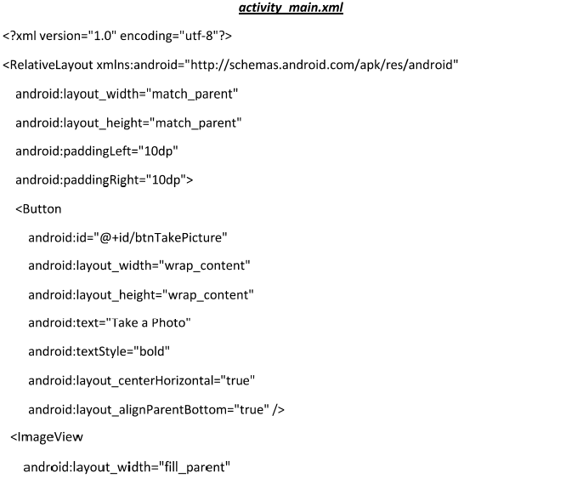

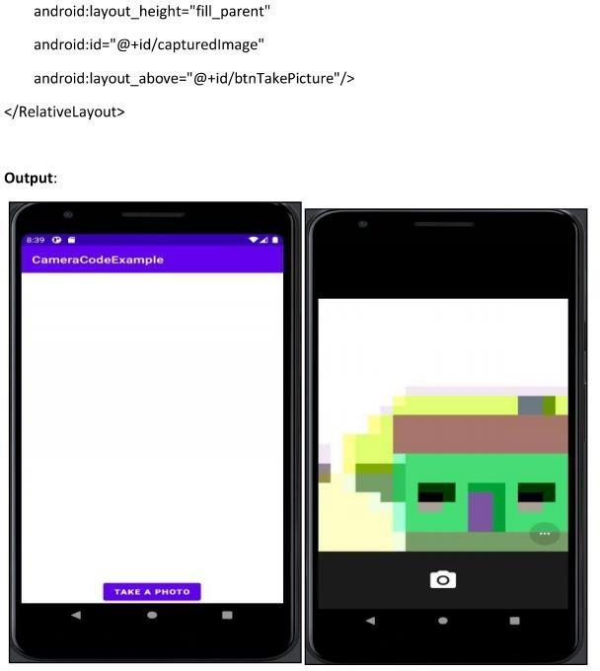



## PS Report

**Abstract:**

Due to the sudden explosion of the smartphone markets, IDE’s like Android Studio, Flutter, etc. came into limelight more and more as many apps where needed for the daily lives of the people using those smartphones. Due to the unforeseen situations, there was an existential crisis for learning apps and step up on this situation we came up with an app that will be useful in learning as well as in entertainment purpose for the masses who want to learn but are bored with the basic methods. So keeping in mind the cognizant method of learning among the people, an interactive method was deployed with the help of android studio to keep the people indulged in it so they could steamroll the process.

## Introduction:

Android is one of the most widely used mobile operating systems. The Android framework helps developers to monitor and operate Android devices by writing controlled code in Java.Android Studio is a popular IDE created by Google for creating Android apps. It's worth noting that Android Studio has supplanted Eclipse as the preferred IDE for creating Android apps. Android comes with a software development kit (SDK) that allows you to build applications for Android users by writing original code and assembling software modules. Android now has an online store where you can buy and sell apps. Android, as a whole, describes a smartphone app community. Android is the most common smartphone app in the world, powering hundreds of millions of smartphones in more than 190 countries. It has the most users of any smartphone network and is already rising rapidly. Every day, a million new Android users turn on their smartphones for the first time and begin searching for apps, games, and other interactive content.

## Motivation:

The rapid increase of Android as the preferred mode of operating system for millions of users around the world has ensured that there are enough tools and software's to develop for people to provide services on the platform. While there are hordes of android quiz applications, there are very few that cater to specifically to the needs of the students. So theprimary motivation behind the development of our application is that the students must have an application which has topics from their subject’s module. And so they can be evaluated not only on the basis of the entire subject but even the focus should be there on different levels of learning which is developed in the student. This was achieved by us through giving various levels of difficulty to the user and framing our questions in accordance to the bloomstaxonomy.

## Problem Statement-

To create an interactive and indulgent Android quiz game application for Software Engineering

## Implementation-

Our entire project was developed using Android Studio for Mobile application. Java was our preferred method of language for development on Android Studio. Various images from open source websites were taken to improve the design elements of the application.

For the quiz application: -

* The questions were stored using Array<string> class in the format where questions and answers are in the format *{"Question", "Right Answer", "Choice1", "Choice2", "Choice3"}*.
* This is where we also divided the questions by their difficulty and in accordance toBloom’s Taxonomy.
* A random function was used to ensure that the same questions are not repeated

The various sections of the application are as follows:

* The Main screen is the splash screen – where the user has to click on the start button to continue.
* Splash Screen directs the user to the Start Screen where the user has to begin the game from newbie level which is the first level of the three level quiz game.
* Once they clear newbie level, they will be guided to the next level – Intermediate level.
* Intermediate level will have more number of questions with increased difficulty. Once the user qualifies the minimum number of questions, they will be directed to the Expert level.
* In all the levels, the user will have chat interaction wherein they will face questions and they have to select one of the four options.
* In the newbie level, the user need to answer 10 set of questions each having 5 marks. In case the student fails to score 20 marks, they will again go through set of questions.
* In the intermediate level, the user need to answer 15 set of questions each having 5 marks. In case the student fails to score 30 marks, they will again go through set of questions.
* These set of questions will keep on shuffling as it is implemented using Random class.

## Code-

* 1. **SplashScreen.java**

package com.example.softwareengmodel;

import androidx.appcompat.app.AppCompatActivity; import android.content.Intent;

import android.os.Bundle; import android.view.View;

import android.view.WindowManager; import android.view.animation.Animation;

import android.view.animation.AnimationUtils; import android.widget.Button;

import android.widget.TextView;

public class SplashScreen extends AppCompatActivity {

Animation topAnim, bottomAnim; Button start;

TextView title, title2, info;

@Override

protected void onCreate(Bundle savedInstanceState) { super.onCreate(savedInstanceState);

getWindow().setFlags(WindowManager.LayoutParams.FLAG_FULLSCREEN, WindowManager.LayoutParams.FLAG_FULLSCREEN);

setContentView(R.layout.splash_screen);

topAnim = AnimationUtils.loadAnimation(this, R.anim.top_animation); bottomAnim = AnimationUtils.loadAnimation(this,

R.anim.bottom_animation);

title = findViewById(R.id.Title); title2 = findViewById(R.id.Title2); info = findViewById(R.id.info); start = findViewById(R.id.menu);

title.setAnimation(topAnim); title2.setAnimation(topAnim); info.setAnimation(bottomAnim); start.setAnimation(bottomAnim);

start.setOnClickListener(new View.OnClickListener() { @Override

public void onClick(View v) {

Intent intent = new Intent(SplashScreen.this, StartPage.class); startActivity(intent);

}

});

}

}



## splash_screen.xml

<?xml version="1.0" encoding="utf-8"?>

<LinearLayout xmlns:android="[http://schemas.android.com/apk/res/android"](http://schemas.android.com/apk/res/android) xmlns:app="[http://schemas.android.com/apk/res-auto"](http://schemas.android.com/apk/res-auto) xmlns:tools="[http://schemas.android.com/tools"](http://schemas.android.com/tools) android:layout_width="match_parent" android:layout_height="match_parent" android:background="@drawable/bg_office" android:orientation="vertical" tools:context="com.example.softwareengmodel.SplashScreen">

<TextView android:id="@+id/Title" android:layout_width="300dp"

android:layout_height="wrap_content" android:layout_marginTop="160dp" android:layout_marginStart="55dp" android:layout_marginEnd="50dp" android:fontFamily="@font/bangers" android:gravity="center" android:text="Welcome To" android:textColor="@color/black" android:textSize="70dp" />

<TextView android:id="@+id/Title2" android:layout_width="260dp"

android:layout_height="wrap_content" android:layout_marginTop="-20dp" android:layout_marginStart="75dp"

android:layout_marginEnd="85dp" android:fontFamily="@font/bangers" android:gravity="center" android:text="THE OFFICE" android:textColor="@color/black" android:textSize="70dp" />

<TextView android:id="@+id/info" android:layout_width="316dp"

android:layout_height="wrap_content" android:layout_marginStart="50dp" android:layout_marginTop="5dp" android:layout_marginEnd="45dp" android:fontFamily="@font/bree_serif" android:gravity="center"

android:text="A Software Engineering Game" android:textColor="@color/black" android:textSize="22dp" android:textStyle="bold" />

<Button

android:id="@+id/menu" android:layout_width="200dp" android:layout_height="wrap_content" android:layout_marginTop="115dp" android:layout_marginStart="105dp" android:layout_marginEnd="80dp" android:padding="8dp" android:backgroundTint="#ffffff" android:fontFamily="@font/bree_serif" android:gravity="center" android:textSize="28dp" android:text="START" android:textColor="@color/black"

android:elevation="45dp" app:cornerRadius="25dp">

</Button>

</LinearLayout>

## StartPage.java

package com.example.softwareengmodel;

import androidx.appcompat.app.AppCompatActivity; import android.content.Context;

import android.content.Intent; import android.os.Bundle; import android.view.View;

import android.view.WindowManager; import android.widget.Button;

import android.widget.TextView; import android.widget.Toast;

public class StartPage extends AppCompatActivity {

int count = 0;

Button newbie, intermediate, expert, result; TextView title, info;

int totalScore = 0;

@Override

protected void onCreate(Bundle savedInstanceState) { super.onCreate(savedInstanceState);

getWindow().setFlags(WindowManager.LayoutParams.FLAG_FULLSCREEN, WindowManager.LayoutParams.FLAG_FULLSCREEN);

setContentView(R.layout.start_page);

title = findViewById(R.id.Title); info = findViewById(R.id.info);

newbie = findViewById(R.id.newbie); intermediate = findViewById(R.id.intermediate); expert = findViewById(R.id.expert);

result = findViewById(R.id.result); Context context = getApplicationContext(); this.totalScore = Result.totalScore;

newbie.setOnClickListener(new View.OnClickListener() { @Override

public void onClick(View v) {

Intent intent = new Intent(StartPage.this, Newbie_intro.class); startActivity(intent);

}

});

intermediate.setOnClickListener(new View.OnClickListener() { @Override

public void onClick(View v) { if(Result.totalScore <= 20 ){

Toast.makeText(context,"You have to solve level 1 to view score " , Toast.LENGTH_SHORT).show();

Intent intent = new Intent(StartPage.this, Newbie_intro.class); startActivity(intent);

}

else {

Intent intent = new Intent(StartPage.this, Intermediate_intro.class); startActivity(intent);

}

}

});

expert.setOnClickListener(new View.OnClickListener() { @Override

public void onClick(View v) { if(Result.totalScore <= 30 ){

Toast.makeText(context,"You have to solve level 2 to view score " , Toast.LENGTH_SHORT).show();

Intent intent = new Intent(StartPage.this, Newbie_intro.class); startActivity(intent);

}

}

});

result.setOnClickListener(new View.OnClickListener() { @Override

public void onClick(View v) { if(count == 0 ){

Toast.makeText(context,"You have to solve level 1 to view score " , Toast.LENGTH_LONG).show();

Intent intent = new Intent(StartPage.this, Newbie_intro.class); startActivity(intent);

}

else{

Intent intent = new Intent(StartPage.this, Result.class); startActivity(intent);

}

}

});

}

}

## start_page.xml

<?xml version="1.0" encoding="utf-8"?>

<LinearLayout xmlns:android="[http://schemas.android.com/apk/res/android"](http://schemas.android.com/apk/res/android) xmlns:app="[http://schemas.android.com/apk/res-auto"](http://schemas.android.com/apk/res-auto)

xmlns:tools="[http://schemas.android.com/tools"](http://schemas.android.com/tools) android:layout_width="match_parent" android:layout_height="match_parent" android:background="@drawable/bg_office" android:orientation="vertical" tools:context="com.example.softwareengmodel.StartPage">

<TextView android:id="@+id/Title" android:layout_width="300dp"

android:layout_height="wrap_content" android:layout_marginTop="45dp" android:layout_marginStart="55dp" android:layout_marginEnd="50dp" android:fontFamily="@font/bangers" android:gravity="center" android:text="The Office" android:textColor="@color/black" android:textSize="70dp" />

<TextView android:id="@+id/info" android:layout_width="316dp"

android:layout_height="wrap_content" android:layout_marginStart="50dp" android:layout_marginTop="-10dp" android:layout_marginEnd="45dp" android:fontFamily="@font/bree_serif" android:gravity="center"

android:text="A Software Engineering Game" android:textColor="@color/black" android:textSize="23dp" android:textStyle="bold" />

<Button

android:id="@+id/newbie" android:layout_width="330dp" android:layout_height="wrap_content" android:layout_marginStart="40dp" android:layout_marginTop="80dp" android:backgroundTint="#ffffff" android:elevation="45dp" android:fontFamily="@font/bree_serif" android:gravity="center" android:padding="12dp" android:text="Level 1: Newbie" android:textColor="@color/black" android:textSize="20dp" android:textStyle="bold" app:cornerRadius="12dp" />

<Button

android:id="@+id/intermediate" android:layout_width="330dp" android:layout_height="wrap_content" android:layout_marginStart="40dp" android:layout_marginTop="40dp" android:layout_marginEnd="30dp" android:backgroundTint="#ffffff" android:elevation="45dp" android:fontFamily="@font/bree_serif" android:gravity="center" android:padding="12dp" android:text="Level 2: intermediate" android:textColor="@color/black" android:textSize="20dp" android:textStyle="bold" app:cornerRadius="12dp" />

<Button

android:id="@+id/expert" android:layout_width="330dp" android:layout_height="wrap_content" android:layout_marginStart="40dp" android:layout_marginTop="40dp" android:backgroundTint="#ffffff" android:fontFamily="@font/bree_serif" android:gravity="center" android:padding="12dp" android:text="Level 3: Expert" android:textColor="@color/black" android:textSize="20dp" android:textStyle="bold" app:cornerRadius="12dp" android:elevation="40dp"/>

<Button

android:id="@+id/result" android:layout_width="330dp" android:layout_height="wrap_content" android:layout_marginStart="40dp" android:layout_marginTop="40dp" android:backgroundTint="#ffffff" android:elevation="45dp" android:fontFamily="@font/bree_serif" android:gravity="center" android:padding="12dp" android:text="Total Score" android:textColor="@color/black" android:textSize="20dp" android:textStyle="bold" app:cornerRadius="12dp" />

</LinearLayout>

## Newbie_intro.java

package com.example.softwareengmodel;

import androidx.appcompat.app.AppCompatActivity; import android.content.Intent;

import android.os.Bundle; import android.view.View;

import android.view.WindowManager; import android.view.animation.Animation;

import android.view.animation.AnimationUtils; import android.widget.Button;

import android.widget.ImageView; import android.widget.TextView;

import static com.example.softwareengmodel.R.layout.activity_newbie_intro; public class Newbie_intro extends AppCompatActivity {

TextView text1,text2,text3,text4,text5; ImageView img1,img2,img3;

Button start;

Animation leftAnim,rightAnim; String intro[] = {

"Hello and Welcome to the Office, a Software Engineering Game.\n " +

"I assume you are familiar with the fundamentals of Software Engineering and the various models associated with it. " +

"Our employee Ms. Khanna will be asking certain questions that will be related to the fundamental of Software engineering." +

"Best of luck!!",

"Hello Ma’am",

"Hello dear.\nMy name is Ms. Anjali Khanna.",

"Sir instructed me to test your fundamental knowledge of Software Engineering subject.",

"Do not worry much, I won't be asking too difficult :)\n When you are ready,

start the quiz"

};

@Override

protected void onCreate(Bundle savedInstanceState) { super.onCreate(savedInstanceState);

getWindow().setFlags(WindowManager.LayoutParams.FLAG_FULLSCREEN, WindowManager.LayoutParams.FLAG_FULLSCREEN);

setContentView(activity_newbie_intro);

leftAnim = AnimationUtils.loadAnimation(this, R.anim.chat_animation_left); rightAnim = AnimationUtils.loadAnimation(this,

R.anim.chat_animation_right);

img1 = findViewById(R.id.image1); img2 = findViewById(R.id.image2); img3 = findViewById(R.id.image3);

text1 = findViewById(R.id.text1); text2 = findViewById(R.id.text2); text3 = findViewById(R.id.text3); text4 = findViewById(R.id.text4); text5 = findViewById(R.id.text5);

start = findViewById(R.id.quiz);

//boss img1.setAnimation(leftAnim); text1.setAnimation(leftAnim);

//user img2.setAnimation(rightAnim); text2.setAnimation(rightAnim);

//employee

img3.setAnimation(leftAnim); text3.setAnimation(leftAnim); text4.setAnimation(leftAnim); text5.setAnimation(leftAnim);

// Create quizArray from level1.

text1.setText(intro[0]); text2.setText(intro[1]); text3.setText(intro[2]); text4.setText(intro[3]); text5.setText(intro[4]);

start.setOnClickListener(new View.OnClickListener() { @Override

public void onClick(View v) {

}

});

}

}

Intent intent = new Intent(Newbie_intro.this, Newbie_main.class); startActivity(intent);

## activity_newbie_intro.xml

<?xml version="1.0" encoding="utf-8"?>

<LinearLayout xmlns:android="<http://schemas.android.com/apk/res/android>" xmlns:tools="[http://schemas.android.com/tools"](http://schemas.android.com/tools) xmlns:app="[http://schemas.android.com/apk/res-auto"](http://schemas.android.com/apk/res-auto) android:layout_width="match_parent" android:layout_height="match_parent" android:background="@drawable/bg_office" tools:context=".Newbie_intro" android:orientation="vertical">

<TextView

android:id="@+id/mainTitle" android:layout_width="match_parent" android:layout_height="wrap_content" android:background="#000000" android:fontFamily="@font/alice" android:gravity="center" android:text="Level 1: Newbie" android:paddingBottom="8dp" android:paddingTop="30dp" android:textColor="@color/white" android:textSize="25dp" android:textStyle="bold" />

<ImageView android:id="@+id/image1" android:layout_width="60dp" android:layout_height="62dp" android:layout_marginTop="10dp" android:layout_marginStart="10dp" android:src="@drawable/boss"/>

<TextView android:id="@+id/text1"

android:layout_width="wrap_content" android:layout_height="wrap_content" android:layout_marginStart="75dp" android:layout_marginTop="-30dp" android:layout_marginEnd="25dp" android:padding="8dp" android:background="@drawable/chat_left" android:fontFamily="@font/average" android:gravity="center" android:text="Hello" android:textColor="@color/black" android:textSize="15dp"

/>

<ImageView android:id="@+id/image2" android:layout_width="60dp" android:layout_height="62dp" android:layout_gravity="right" android:layout_marginTop="10dp" android:layout_marginEnd="10dp"

android:src="@drawable/user_image"/>

<TextView android:id="@+id/text2"

android:layout_width="wrap_content" android:layout_height="wrap_content" android:layout_marginTop="-30dp" android:layout_marginStart="20dp" android:layout_marginEnd="75dp" android:layout_gravity="right" android:padding="8dp" android:background="@drawable/chat_right" android:fontFamily="@font/average" android:gravity="right"

android:text="Hello" android:textColor="@color/black" android:textSize="15dp"

/>

<ImageView android:id="@+id/image3" android:layout_width="60dp" android:layout_height="62dp" android:layout_marginTop="10dp" android:layout_marginStart="10dp" android:src="@drawable/level1"/>

<TextView

android:id="@+id/text3" android:layout_width="wrap_content" android:layout_height="wrap_content" android:layout_marginStart="75dp" android:layout_marginTop="-30dp" android:layout_marginEnd="25dp" android:padding="8dp" android:background="@drawable/chat_left" android:fontFamily="@font/average" android:gravity="center" android:text="Hello" android:textColor="@color/black" android:textSize="15dp"/>

<TextView android:id="@+id/text4"

android:layout_width="wrap_content" android:layout_height="wrap_content" android:layout_marginStart="75dp" android:layout_marginTop="15dp" android:layout_marginEnd="25dp" android:padding="8dp" android:background="@drawable/chat_left" android:fontFamily="@font/average" android:gravity="center" android:text="Hello" android:textColor="@color/black" android:textSize="15dp"

/>

<TextView android:id="@+id/text5"

android:layout_width="wrap_content" android:layout_height="wrap_content" android:layout_marginStart="75dp" android:layout_marginTop="15dp" android:layout_marginEnd="25dp"

android:padding="8dp" android:background="@drawable/chat_left" android:fontFamily="@font/average" android:gravity="center" android:text="Hello" android:textColor="@color/black" android:textSize="15dp"

/>

<Button

android:id="@+id/quiz" android:layout_width="wrap_content" android:layout_height="wrap_content" android:layout_marginTop="20dp" android:backgroundTint="#ffffff" android:fontFamily="@font/bree_serif" android:layout_gravity="center" android:padding="15dp" android:text="Start quiz" android:textColor="@color/black" android:textSize="20dp" app:cornerRadius="12dp" android:elevation="45dp"/>

</LinearLayout>

## Newbie_main.java

package com.example.softwareengmodel;

import androidx.appcompat.app.AppCompatActivity; import android.os.Bundle;

import android.content.Intent; import android.view.View;

import android.view.WindowManager; import android.widget.Button;

import android.widget.TextView;

import java.util.ArrayList; import java.util.Collections; import java.util.Random;

public class Newbie_main extends AppCompatActivity {

private TextView question;

private Button answerBtn1, answerBtn2, answerBtn3, answerBtn4;

private String rightAnswer ; private int rightAnswerCount = 0; private int quizCount = 1;

static final private int QUIZ_COUNT = 10;

ArrayList<ArrayList<String>> quizArray = new ArrayList<>(); String level1[][] = {

// {"Question", "Right Answer", "Choice1", "Choice2", "Choice3"}

{"It is a piece of programming code which performs a well defined task.", "Computer Program",

"Computer Software", "Virus", "Debugging"},

{"A system can be defined as", "All of the mentioned",

"A collection of people, machines, and methods organized to accomplish a set of functions",

"An integrated whole that is composed of diverse, interacting specialized structures and sub-functions",

"A group of subsystems united by some interaction or interdependence performing many duties but functioning as a single unit"},

{"A person who writes a program for running the hardware of a computer is called",

"Programmer", " Data processor", "System designer", "System

analyst"},

{"The main activity of the design phase of the system life cycle is to?", "Propose alternatives to the current system", "Replace the old system

with the new one",

"Develop and test the new system", "Understand the current system"},

{"What is Software ?", "Set of computer programs, procedures and possibly

is a " + computer",

"collection of instructions that enable the user to interact with a "A set of compiler instructions", "A mathematical formula", "Things

which we can touch"},

{"A Software consists of", "Set of Programs + documentation + operating procedures",

"Set of programs", "Set of instructions + operating procedures", "Programs + hardware manuals"},

{"How many stages does the DevOp model have ?", "5 stages", "3 stages", "2 stages", "6 stages"},

{"CMM stands for", "Capability Maturity Model", "Capability Maturity Module",

"Capability Management Module", "Conservative Maturity Model"},

{"DevOps stands for", "Development And Operations", "Digital and Operations", "Drive and Operations",

"None of the above"},

{"How many phases are there in Scrum", "Three", "Two",

"Scrum is an agile method which means it does not have phases",

"Four"},

{"RAD stands for", "Rapid Application Development", "Rapid Application Document",

"Relative Application Development", "Random Application Development"},

{"RAD Model has", "5 phases", "2 phases", "3 phases", "6 phases"},

{"SDLC stands for", "Software Development Life Cycle", "System Development Life cycle",

"Software Design Life Cycle", "System Design Life Cycle"},

};

@Override

protected void onCreate(Bundle savedInstanceState) { super.onCreate(savedInstanceState);

getWindow().setFlags(WindowManager.LayoutParams.FLAG_FULLSCREEN, WindowManager.LayoutParams.FLAG_FULLSCREEN);

setContentView(R.layout.activity_newbie_main);

question = findViewById(R.id.question); answerBtn1 = findViewById(R.id.answerBtn1); answerBtn2 = findViewById(R.id.answerBtn2); answerBtn3 = findViewById(R.id.answerBtn3); answerBtn4 = findViewById(R.id.answerBtn4);

// Create quizArray from level1.

for (int i = 0; i < level1.length; i++) {

// Prepare array.

ArrayList<String> tmpArray = new ArrayList<>(); tmpArray.add(level1[i][0]); // Country tmpArray.add(level1[i][1]); // Right Answer tmpArray.add(level1[i][2]); // Choice1 tmpArray.add(level1[i][3]); // Choice2 tmpArray.add(level1[i][4]); // Choice3

// Add tmpArray to quizArray. quizArray.add(tmpArray);

}

showNextQuiz();

}

public void showNextQuiz() {

// Generate random number between 0 and 14 (quizArray's size - 1) Random random = new Random();

int randomNum = random.nextInt(quizArray.size());

// Pick one quiz set.

ArrayList<String> quiz = quizArray.get(randomNum);

// Set question and right answer.

// Array format: {"Question", "Right Answer", "Choice1", "Choice2", "Choice3"}

question.setText(quiz.get(0)); rightAnswer = quiz.get(1);

// Remove "Question" from quiz and Shuffle choices. quiz.remove(0);

Collections.shuffle(quiz);

// Set choices. answerBtn1.setText(quiz.get(0)); answerBtn2.setText(quiz.get(1)); answerBtn3.setText(quiz.get(2)); answerBtn4.setText(quiz.get(3));

// Remove this quiz from quizArray. quizArray.remove(randomNum);

}

public void checkAnswer(View view) {

// Get pushed button.

Button answerBtn = findViewById(view.getId()); String btnText = answerBtn.getText().toString();

if (btnText.equals(rightAnswer)) { rightAnswerCount++;

}

if (quizCount == QUIZ_COUNT) {

// Show Result.

Intent intent = new Intent(getApplicationContext(), Result.class); intent.putExtra("RIGHT_ANSWER_COUNT", rightAnswerCount); intent.putExtra("TOTAL_COUNT", QUIZ_COUNT); startActivity(intent);

} else {

quizCount++; showNextQuiz();

}

}

}

## activity_newbie_main.xml

<?xml version="1.0" encoding="utf-8"?>

<LinearLayout xmlns:android="[http://schemas.android.com/apk/res/android"](http://schemas.android.com/apk/res/android) xmlns:app="[http://schemas.android.com/apk/res-auto"](http://schemas.android.com/apk/res-auto) xmlns:tools="[http://schemas.android.com/tools"](http://schemas.android.com/tools) android:layout_width="match_parent" android:layout_height="match_parent"

tools:context=".Newbie_main" android:background="@drawable/bg_office" android:orientation="vertical">

<TextView android:id="@+id/mainTitle" android:layout_width="match_parent" android:layout_height="wrap_content" android:background="#000000" android:fontFamily="@font/alice" android:gravity="center" android:text="Level 1: Newbie" android:paddingBottom="8dp" android:paddingTop="30dp" android:textColor="@color/white" android:textSize="25dp" android:textStyle="bold" />

<LinearLayout android:layout_width="match_parent" android:layout_height="match_parent" android:orientation="vertical" android:layout_margin="10dp">

<ImageView

android:id="@+id/user_image" android:layout_width="60dp" android:layout_height="62dp" android:src="@drawable/level1"/>

<TextView android:id="@+id/question"

android:layout_width="wrap_content" android:layout_height="wrap_content" android:layout_marginTop="-30dp" android:layout_marginEnd="22dp" android:layout_marginStart="70dp" android:layout_gravity="left" android:fontFamily="@font/average" android:padding="15dp" android:background="@drawable/chat_left" android:text="Hi" android:textColor="#000000" android:textSize="20dp" />

<ImageView

android:id="@+id/student_image" android:layout_width="60dp" android:layout_height="62dp" android:layout_gravity="right" android:layout_marginTop="40dp"

android:src="@drawable/user_image"/>

<androidx.appcompat.widget.AppCompatButton android:id="@+id/answerBtn1" android:layout_width="wrap_content" android:layout_height="wrap_content" android:layout_marginTop="-30dp" android:layout_marginStart="20dp" android:layout_marginEnd="70dp" android:layout_gravity="right" android:padding="18dp" android:background="@drawable/chat_right" android:text="Answer 1" android:textSize="15dp" android:textColor="@color/black" android:fontFamily="@font/average" android:elevation="45dp" android:onClick="checkAnswer"

/>

<androidx.appcompat.widget.AppCompatButton android:id="@+id/answerBtn2" android:layout_width="wrap_content" android:layout_height="wrap_content" android:layout_marginTop="15dp" android:layout_marginStart="20dp" android:layout_marginEnd="70dp" android:layout_gravity="right" android:padding="18dp" android:background="@drawable/chat_right" android:text="Answer 2" android:textSize="15dp" android:textColor="@color/black" android:fontFamily="@font/average" android:elevation="45dp"

android:onClick="checkAnswer"/>

<androidx.appcompat.widget.AppCompatButton android:id="@+id/answerBtn3" android:layout_width="wrap_content" android:layout_height="wrap_content" android:layout_gravity="right" android:layout_marginStart="20dp" android:layout_marginTop="15dp" android:layout_marginEnd="70dp" android:background="@drawable/chat_right" android:elevation="45dp" android:fontFamily="@font/average" android:gravity="center" android:onClick="checkAnswer" android:padding="18dp" android:text="Answer 3" android:textColor="@color/black" android:textSize="15dp" />

<androidx.appcompat.widget.AppCompatButton android:id="@+id/answerBtn4" android:layout_width="wrap_content" android:layout_height="wrap_content" android:layout_marginTop="15dp" android:layout_marginStart="20dp" android:layout_marginEnd="70dp" android:layout_gravity="right" android:padding="18dp" android:gravity="center" android:background="@drawable/chat_right" android:text="Answer 4" android:textSize="15dp" android:textColor="@color/black" android:fontFamily="@font/average" android:elevation="45dp"

android:onClick="checkAnswer"/>

</LinearLayout>

</LinearLayout>

## Intermediate_intro.java

package com.example.softwareengmodel;

import androidx.appcompat.app.AppCompatActivity; import android.content.Intent;

import android.os.Bundle; import android.view.View;

import android.view.WindowManager; import android.view.animation.Animation;

import android.view.animation.AnimationUtils; import android.widget.Button;

import android.widget.ImageView; import android.widget.TextView;

public class Intermediate_intro extends AppCompatActivity {

TextView text1,text2,text3,text4,text5,text6,text7; ImageView img1,img2,img3;

Button start;

Animation leftAnim,rightAnim; String intro[] = {

"Well Done Newbie!!\n As you have scored really well, we grant you a PROMOTION",

"Welcome to the Intermediate level and definitely you will have raise in salary",

"Now, your fundamentals of Software engineering is strong." +

" Our manager Mr. Malhotra will be asking furthur questions related to the core of Software engineering.",

"Greetings Sir",

"Hello. My name is Mr. Raj Malhotra. I am the manager of this firm",

"Sir instructed me to test your core knowledge of Software Engineering subject.",

"Haha, I will be asking bit medium level questions :)\n When you are ready, start the quiz"

};

@Override

protected void onCreate(Bundle savedInstanceState) { super.onCreate(savedInstanceState);

getWindow().setFlags(WindowManager.LayoutParams.FLAG_FULLSCREEN, WindowManager.LayoutParams.FLAG_FULLSCREEN);

setContentView(R.layout.activity_intermediate_intro);

leftAnim = AnimationUtils.loadAnimation(this, R.anim.chat_animation_left); rightAnim = AnimationUtils.loadAnimation(this,

R.anim.chat_animation_right);

img1 = findViewById(R.id.image1); img2 = findViewById(R.id.image2); img3 = findViewById(R.id.image3);

text1 = findViewById(R.id.text1); text2 = findViewById(R.id.text2); text3 = findViewById(R.id.text3); text4 = findViewById(R.id.text4); text5 = findViewById(R.id.text5); text6 = findViewById(R.id.text6); text7 = findViewById(R.id.text7);

start = findViewById(R.id.quiz);

//boss img1.setAnimation(leftAnim); text1.setAnimation(leftAnim);

text2.setAnimation(leftAnim); text3.setAnimation(leftAnim);

//user img2.setAnimation(rightAnim); text4.setAnimation(rightAnim);

//manager img3.setAnimation(leftAnim); text5.setAnimation(leftAnim); text6.setAnimation(leftAnim); text7.setAnimation(leftAnim);

// Create quizArray from level1.

text1.setText(intro[0]); text2.setText(intro[1]); text3.setText(intro[2]); text4.setText(intro[3]); text5.setText(intro[4]); text6.setText(intro[5]); text7.setText(intro[6]);

start.setOnClickListener(new View.OnClickListener() { @Override

public void onClick(View v) {

Intent intent = new Intent(Intermediate_intro.this, Intermediate_main.class);

startActivity(intent);

}

});

}

}



## activity_intermediate_intro.xml

<?xml version="1.0" encoding="utf-8"?>

<LinearLayout xmlns:android="<http://schemas.android.com/apk/res/android>" xmlns:tools="[http://schemas.android.com/tools"](http://schemas.android.com/tools) xmlns:app="[http://schemas.android.com/apk/res-auto"](http://schemas.android.com/apk/res-auto) android:layout_width="match_parent" android:layout_height="match_parent" android:background="@drawable/bg_office" tools:context=".Newbie_intro" android:orientation="vertical">

<TextView android:id="@+id/mainTitle" android:layout_width="match_parent" android:layout_height="wrap_content" android:background="#000000" android:fontFamily="@font/alice" android:gravity="center" android:text="Level 2: Intermediate" android:paddingBottom="8dp" android:paddingTop="30dp" android:textColor="@color/white" android:textSize="25dp" android:textStyle="bold" />

<ImageView android:id="@+id/image1" android:layout_width="60dp" android:layout_height="62dp" android:layout_marginTop="10dp" android:layout_marginStart="10dp" android:src="@drawable/boss"/>

<TextView android:id="@+id/text1"

android:layout_width="wrap_content" android:layout_height="wrap_content" android:layout_marginStart="75dp" android:layout_marginTop="-30dp" android:layout_marginEnd="25dp" android:padding="8dp" android:background="@drawable/chat_left" android:fontFamily="@font/average" android:gravity="center" android:text="Hello" android:textColor="@color/black" android:textSize="15dp"

/>

<TextView android:id="@+id/text2"

android:layout_width="wrap_content" android:layout_height="wrap_content" android:layout_marginStart="75dp" android:layout_marginTop="10dp" android:layout_marginEnd="25dp" android:padding="8dp" android:background="@drawable/chat_left" android:fontFamily="@font/average" android:gravity="center" android:text="Hello" android:textColor="@color/black" android:textSize="15dp"

/>

<TextView android:id="@+id/text3"

android:layout_width="wrap_content" android:layout_height="wrap_content" android:layout_marginStart="75dp"

android:layout_marginTop="10dp" android:layout_marginEnd="25dp" android:padding="8dp" android:background="@drawable/chat_left" android:fontFamily="@font/average" android:gravity="center" android:text="Hello" android:textColor="@color/black" android:textSize="15dp"

/>

<ImageView android:id="@+id/image2" android:layout_width="60dp" android:layout_height="62dp" android:layout_gravity="right" android:layout_marginTop="10dp" android:layout_marginEnd="10dp"

android:src="@drawable/user_image"/>

<TextView android:id="@+id/text4"

android:layout_width="wrap_content" android:layout_height="wrap_content" android:layout_marginTop="-30dp" android:layout_marginStart="20dp" android:layout_marginEnd="75dp" android:layout_gravity="right" android:padding="8dp" android:background="@drawable/chat_right" android:fontFamily="@font/average" android:gravity="right"

android:text="Hello" android:textColor="@color/black" android:textSize="15dp"

/>

<ImageView android:id="@+id/image3" android:layout_width="60dp" android:layout_height="62dp" android:layout_marginTop="10dp" android:layout_marginStart="10dp" android:src="@drawable/level2"/>

<TextView android:id="@+id/text5"

android:layout_width="wrap_content" android:layout_height="wrap_content" android:layout_marginStart="75dp" android:layout_marginTop="-30dp" android:layout_marginEnd="25dp" android:padding="8dp" android:background="@drawable/chat_left" android:fontFamily="@font/average" android:gravity="center" android:text="Hello" android:textColor="@color/black" android:textSize="15dp"/>

<TextView android:id="@+id/text6"

android:layout_width="wrap_content" android:layout_height="wrap_content" android:layout_marginStart="75dp" android:layout_marginTop="10dp" android:layout_marginEnd="25dp" android:padding="8dp" android:background="@drawable/chat_left" android:fontFamily="@font/average" android:gravity="center" android:text="Hello"

android:textColor="@color/black" android:textSize="15dp"

/>

<TextView android:id="@+id/text7"

android:layout_width="wrap_content" android:layout_height="wrap_content" android:layout_marginStart="75dp" android:layout_marginTop="10dp" android:layout_marginEnd="25dp" android:padding="8dp" android:background="@drawable/chat_left" android:fontFamily="@font/average" android:gravity="center" android:text="Hello" android:textColor="@color/black" android:textSize="15dp"

/>

<Button

android:id="@+id/quiz" android:layout_width="wrap_content" android:layout_height="wrap_content" android:layout_marginTop="10dp" android:backgroundTint="#ffffff" android:fontFamily="@font/bree_serif" android:layout_gravity="center" android:padding="15dp" android:text="Start quiz" android:textColor="@color/black" android:textSize="20dp" app:cornerRadius="12dp" android:elevation="45dp"/>

</LinearLayout>

## Intermediate_main.java

package com.example.softwareengmodel;

import androidx.appcompat.app.AppCompatActivity; import android.os.Bundle;

import android.content.Intent; import android.view.View;

import android.view.WindowManager; import android.widget.Button;

import android.widget.TextView; import java.util.ArrayList; import java.util.Collections; import java.util.Random;

public class Intermediate_main extends AppCompatActivity {

private TextView question;

private Button answerBtn1, answerBtn2, answerBtn3, answerBtn4;

private String rightAnswer ; private int rightAnswerCount = 0; private int quizCount = 1;

static final private int QUIZ_COUNT = 15; ArrayList<ArrayList<String>> quizArray = new ArrayList<>(); String level2[][] = {

// {"Question", "Right Answer", "Choice1", "Choice2", "Choice3"}

{

"Which of the following statements best describes the goal of DevOps?", "Establish an environment to release more reliable applications faster", "Establish an environment where the release of applications is valued more

than its quality.",

"Establish an environment where application development performs all the operation tasks",

"Establish an environment where change management does not control

application releases"

},

{

"What are the key components of DevOps?",

"All of the above", "Continuous Delivery & Monitoring", "Continuous Testing", "Continuous Integration"

},

{ "DevOps is an extension of ? ", "Agile", "Waterfall", "RAD model", "None of the above"},

{"Which of these terms are level names in the Capability Maturity Model?", "Performed", "Repeated", "Optimized", "None of the above"

},

{"Which of the following is not a maturity level in CMM?", " Design", "Repeatable", "Managed", "Optimizing"},

{"What are the advantages of the CMM model?",

"It guides towards repeatable standard processes and hence reduces the learning time on how to get things done.",

"CMM determines what a process should address instead of how it should be implemented.",

"Both of i and ii", "None of the above"

},

{"The CMM emphasizes?", "the need to record information", "continuous process improvement",

"the need to accept quality system", "None of the above"

},

{"Which of the following is not associated with Agile Manufacturing?", "Slow approach", "Operator augmentation", "Bottom-up innovation",

"Operational Flexibility"},

{"Which of the following is not a reason for organizations to adopt flexible systems under agile manufacturing?",

"Waterfall model", "Political factors", "Economic factors", "Increasing fluctuations in demand"

},

{"Agile Software Development is based on", "Both Incremental and Iterative Development",

"Linear Development", "Iterative Development", "Incremental

Development"

},

{"How is plan driven development different from agile development ?", " Iteration occurs within activities", " All of the mentioned",

"Specification, design, implementation and testing are interleaved", "Outputs are decided through a process of negotiation during the software

development process"

},

{"Which of the following does not apply to agility to a software process? ",

"Eliminate the use of project planning and testing", "Only essential work products are produced",

" Uses incremental product delivery strategy", "All of the mentioned"

},

{"Which of the following is not a validation activity", " Walkthroughs", "Acceptance testing", " System testing", " Unit testing"

},

{"Which of the following is not a verification activity", " Acceptance testing", "Inspections", "Walkthroughs", " Buddy check"},

{"A planned meeting is also known as a", "Formal review", "Informal review", "Technical review ", "Dynamic review"},

{"Which one of the following is not a phase of Prototyping Model?", "Coding", "Quick Design", "Prototype Refinement", "Engineer Product"},

{"Which of the following statements regarding Build & Fix Model is wrong?", "It scales up well to large projects", "No room for structured design", "Code soon becomes unfixable & unchangeable", "Maintenance is

practically not possible"

},

{"A model that is the demo implementation of the system.", "prototype", "waterfall", "incremental", "agile"},

{"A stage in which individual components are integrated and ensured that they are error-free to meet customer requirements.",

"Testing", "Coding", "Design", "Implementation"},

{" is a step in which design is translated into machine-readable form.",

"Coding", "Design", "Conversion", "Debugging"}

};

@Override

protected void onCreate(Bundle savedInstanceState) { super.onCreate(savedInstanceState);

getWindow().setFlags(WindowManager.LayoutParams.FLAG_FULLSCREEN, WindowManager.LayoutParams.FLAG_FULLSCREEN);

setContentView(R.layout.activity_intermediate_main);

question = findViewById(R.id.question); answerBtn1 = findViewById(R.id.answerBtn1); answerBtn2 = findViewById(R.id.answerBtn2); answerBtn3 = findViewById(R.id.answerBtn3); answerBtn4 = findViewById(R.id.answerBtn4);

// Create quizArray from level1.

for (int i = 0; i < level2.length; i++) {

// Prepare array.

ArrayList<String> tmpArray = new ArrayList<>(); tmpArray.add(level2[i][0]); // Country tmpArray.add(level2[i][1]); // Right Answer tmpArray.add(level2[i][2]); // Choice1 tmpArray.add(level2[i][3]); // Choice2 tmpArray.add(level2[i][4]); // Choice3

// Add tmpArray to quizArray. quizArray.add(tmpArray);

}

showNextQuiz();

}

public void showNextQuiz() {

// Generate random number between 0 and 14 (quizArray's size - 1) Random random = new Random();

int randomNum = random.nextInt(quizArray.size());

// Pick one quiz set.

ArrayList<String> quiz = quizArray.get(randomNum);

// Set question and right answer.

// Array format: {"Question", "Right Answer", "Choice1", "Choice2", "Choice3"}

question.setText(quiz.get(0)); rightAnswer = quiz.get(1);

// Remove "Question" from quiz and Shuffle choices. quiz.remove(0);

Collections.shuffle(quiz);

// Set choices. answerBtn1.setText(quiz.get(0)); answerBtn2.setText(quiz.get(1)); answerBtn3.setText(quiz.get(2)); answerBtn4.setText(quiz.get(3));

// Remove this quiz from quizArray. quizArray.remove(randomNum);

}

public void checkAnswer(View view) {

// Get pushed button.

Button answerBtn = findViewById(view.getId()); String btnText = answerBtn.getText().toString();

if (btnText.equals(rightAnswer)) { rightAnswerCount++;

}

if (quizCount == QUIZ_COUNT) {

// Show Result.

Intent intent = new Intent(getApplicationContext(), Result.class); intent.putExtra("RIGHT_ANSWER_COUNT", rightAnswerCount); intent.putExtra("TOTAL_COUNT", QUIZ_COUNT); startActivity(intent);

} else {

quizCount++; showNextQuiz();

}

}

}

## activity_intermediate_main.xml

<?xml version="1.0" encoding="utf-8"?>

<LinearLayout xmlns:android="[http://schemas.android.com/apk/res/android"](http://schemas.android.com/apk/res/android) xmlns:tools="[http://schemas.android.com/tools"](http://schemas.android.com/tools) android:layout_width="match_parent" android:layout_height="match_parent"

tools:context=".Newbie_main" android:background="@drawable/bg_office" android:orientation="vertical">

<TextView android:id="@+id/mainTitle" android:layout_width="match_parent" android:layout_height="wrap_content" android:background="#000000"

android:fontFamily="@font/alice" android:gravity="center" android:text="Level 2: Intermediate" android:paddingBottom="8dp" android:paddingTop="30dp" android:textColor="@color/white" android:textSize="25dp" android:textStyle="bold" />

<LinearLayout android:layout_width="match_parent" android:layout_height="match_parent" android:orientation="vertical" android:layout_margin="10dp">

<ImageView

android:id="@+id/user_image" android:layout_width="60dp" android:layout_height="62dp" android:src="@drawable/level2"/>

<TextView android:id="@+id/question"

android:layout_width="wrap_content" android:layout_height="wrap_content" android:layout_marginTop="-30dp" android:layout_marginEnd="22dp" android:layout_marginStart="70dp" android:layout_gravity="left" android:fontFamily="@font/average" android:padding="15dp" android:background="@drawable/chat_left" android:text="Hi" android:textColor="#000000"

android:textSize="20dp" />

<ImageView

android:id="@+id/student_image" android:layout_width="60dp" android:layout_height="62dp" android:layout_gravity="right" android:layout_marginTop="25dp" android:src="@drawable/user_image"/>

<androidx.appcompat.widget.AppCompatButton android:id="@+id/answerBtn1" android:layout_width="wrap_content" android:layout_height="wrap_content" android:layout_marginTop="-30dp" android:layout_marginStart="20dp" android:layout_marginEnd="70dp" android:layout_gravity="right" android:padding="18dp" android:background="@drawable/chat_right" android:text="Answer 1" android:textSize="15dp" android:textColor="@color/black" android:fontFamily="@font/average" android:elevation="45dp" android:onClick="checkAnswer"

/>

<androidx.appcompat.widget.AppCompatButton android:id="@+id/answerBtn2" android:layout_width="wrap_content" android:layout_height="wrap_content" android:layout_marginTop="10dp" android:layout_marginStart="20dp"

android:layout_marginEnd="70dp" android:layout_gravity="right" android:padding="18dp" android:background="@drawable/chat_right" android:text="Answer 2" android:textSize="15dp" android:textColor="@color/black" android:fontFamily="@font/average" android:elevation="45dp" android:onClick="checkAnswer"/>

<androidx.appcompat.widget.AppCompatButton android:id="@+id/answerBtn3" android:layout_width="wrap_content" android:layout_height="wrap_content" android:layout_gravity="right" android:layout_marginStart="10dp" android:layout_marginTop="15dp" android:layout_marginEnd="70dp" android:background="@drawable/chat_right" android:elevation="45dp" android:fontFamily="@font/average" android:gravity="center" android:onClick="checkAnswer" android:padding="18dp" android:text="Answer 3" android:textColor="@color/black" android:textSize="15dp" />

<androidx.appcompat.widget.AppCompatButton android:id="@+id/answerBtn4" android:layout_width="wrap_content" android:layout_height="wrap_content" android:layout_marginTop="10dp" android:layout_marginStart="20dp" android:layout_marginEnd="70dp"

android:layout_gravity="right" android:padding="18dp" android:gravity="center" android:background="@drawable/chat_right" android:text="Answer 4" android:textSize="15dp" android:textColor="@color/black" android:fontFamily="@font/average" android:elevation="45dp" android:onClick="checkAnswer"/>

</LinearLayout>

</LinearLayout>

## Expert_intro.java

package com.example.softwareengmodel;

import androidx.appcompat.app.AppCompatActivity; import android.content.Intent;

import android.os.Bundle; import android.view.View;

import android.view.WindowManager; import android.view.animation.Animation;

import android.view.animation.AnimationUtils; import android.widget.Button;

import android.widget.ImageView; import android.widget.TextView;

public class Expert_intro extends AppCompatActivity {

TextView text1,text2,text3,text4,text5,text6,text7,text8; ImageView img1,img2,img3,img4,img5;

Button start;

Animation leftAnim,rightAnim; String intro[] = {

"Well Done!! Well Done!!\n As you have scored really well, we grant you another PROMOTION",

"Welcome to the Expert level and yes yes you will have raise in the salary as well",

"Now, your core knowledge of Software engineering is strong." +

" Our chief Manager Ms. Sharma will be asking some questions related to the advance Software engineering.",

"Greetings Ma'am",

"Hello. I am Tania Sharma, chief Manager of this firm.", "Pleasure meeting you Ma'am",

"Oh and I have heard a lot about you. So this time I will test your advance knowledge of Software Engineering subject.",

"And yes it wont be easy. \n So when you are ready, start the quiz"

};

@Override

protected void onCreate(Bundle savedInstanceState) { super.onCreate(savedInstanceState);

getWindow().setFlags(WindowManager.LayoutParams.FLAG_FULLSCREEN, WindowManager.LayoutParams.FLAG_FULLSCREEN);

setContentView(R.layout.activity_expert_intro);

leftAnim = AnimationUtils.loadAnimation(this, R.anim.chat_animation_left); rightAnim = AnimationUtils.loadAnimation(this,

R.anim.chat_animation_right);

img1 = findViewById(R.id.image1); img2 = findViewById(R.id.image2); img3 = findViewById(R.id.image3); img4 = findViewById(R.id.image4); img5 = findViewById(R.id.image5);

text1 = findViewById(R.id.text1); text2 = findViewById(R.id.text2);

text3 = findViewById(R.id.text3); text4 = findViewById(R.id.text4); text5 = findViewById(R.id.text5); text6 = findViewById(R.id.text6); text7 = findViewById(R.id.text7);

start = findViewById(R.id.quiz);

//boss img1.setAnimation(leftAnim); text1.setAnimation(leftAnim); text2.setAnimation(leftAnim); text3.setAnimation(leftAnim);

//user img2.setAnimation(rightAnim); text4.setAnimation(rightAnim);

//manager img3.setAnimation(leftAnim); text5.setAnimation(leftAnim);

//user img4.setAnimation(rightAnim); text6.setAnimation(rightAnim);

//manager img5.setAnimation(leftAnim); text7.setAnimation(leftAnim); text8.setAnimation(leftAnim);

text1.setText(intro[0]); text2.setText(intro[1]); text3.setText(intro[2]); text4.setText(intro[3]); text5.setText(intro[4]); text6.setText(intro[5]); text7.setText(intro[6]);

start.setOnClickListener(new View.OnClickListener() { @Override

public void onClick(View v) {

}

});

}

}

Intent intent = new Intent(Expert_intro.this, Expert_main.class); startActivity(intent);



## activity_expert_intro.xml

<?xml version="1.0" encoding="utf-8"?>

<LinearLayout xmlns:android="<http://schemas.android.com/apk/res/android>" xmlns:tools="[http://schemas.android.com/tools"](http://schemas.android.com/tools) xmlns:app="[http://schemas.android.com/apk/res-auto"](http://schemas.android.com/apk/res-auto) android:layout_width="match_parent" android:layout_height="match_parent" android:background="@drawable/bg_office" tools:context=".Newbie_intro" android:orientation="vertical">

<TextView android:id="@+id/mainTitle" android:layout_width="match_parent" android:layout_height="wrap_content" android:background="#000000" android:fontFamily="@font/alice" android:gravity="center" android:text="Level 3: Expert" android:paddingBottom="8dp" android:paddingTop="30dp" android:textColor="@color/white" android:textSize="25dp" android:textStyle="bold" />

<ImageView android:id="@+id/image1" android:layout_width="60dp" android:layout_height="62dp" android:layout_marginTop="10dp" android:layout_marginStart="10dp" android:src="@drawable/boss"/>

<TextView android:id="@+id/text1"

android:layout_width="wrap_content" android:layout_height="wrap_content" android:layout_marginStart="75dp" android:layout_marginTop="-30dp" android:layout_marginEnd="25dp" android:padding="8dp" android:background="@drawable/chat_left" android:fontFamily="@font/average" android:gravity="center" android:text="Hello" android:textColor="@color/black" android:textSize="15dp"

/>

<TextView android:id="@+id/text2"

android:layout_width="wrap_content" android:layout_height="wrap_content" android:layout_marginStart="75dp" android:layout_marginTop="10dp" android:layout_marginEnd="25dp" android:padding="8dp" android:background="@drawable/chat_left" android:fontFamily="@font/average" android:gravity="center" android:text="Hello"

android:textColor="@color/black" android:textSize="15dp"

/>

<TextView android:id="@+id/text3"

android:layout_width="wrap_content" android:layout_height="wrap_content" android:layout_marginStart="75dp" android:layout_marginTop="10dp" android:layout_marginEnd="25dp" android:padding="8dp" android:background="@drawable/chat_left" android:fontFamily="@font/average" android:gravity="center" android:text="Hello" android:textColor="@color/black" android:textSize="15dp"

/>

<ImageView android:id="@+id/image2" android:layout_width="60dp" android:layout_height="62dp" android:layout_gravity="right" android:layout_marginTop="10dp" android:layout_marginEnd="10dp"

android:src="@drawable/user_image"/>

<TextView android:id="@+id/text4"

android:layout_width="wrap_content" android:layout_height="wrap_content" android:layout_marginTop="-30dp" android:layout_marginStart="20dp" android:layout_marginEnd="75dp" android:layout_gravity="right"

android:padding="8dp" android:background="@drawable/chat_right" android:fontFamily="@font/average" android:gravity="right"

android:text="Hello" android:textColor="@color/black" android:textSize="15dp"

/>

<ImageView android:id="@+id/image3" android:layout_width="60dp" android:layout_height="62dp" android:layout_marginTop="10dp" android:layout_marginStart="10dp" android:src="@drawable/level3"/>

<TextView android:id="@+id/text5"

android:layout_width="wrap_content" android:layout_height="wrap_content" android:layout_marginStart="75dp" android:layout_marginTop="-30dp" android:layout_marginEnd="25dp" android:padding="8dp" android:background="@drawable/chat_left" android:fontFamily="@font/average" android:gravity="center" android:text="Hello" android:textColor="@color/black" android:textSize="15dp"/>

<ImageView android:id="@+id/image4" android:layout_width="60dp" android:layout_height="62dp"

android:layout_gravity="right" android:layout_marginTop="10dp" android:layout_marginEnd="10dp" android:src="@drawable/user_image"/>

<TextView android:id="@+id/text6"

android:layout_width="wrap_content" android:layout_height="wrap_content" android:layout_marginTop="-30dp" android:layout_marginStart="20dp" android:layout_marginEnd="75dp" android:layout_gravity="right" android:padding="8dp" android:background="@drawable/chat_right" android:fontFamily="@font/average" android:gravity="right"

android:text="Hello" android:textColor="@color/black" android:textSize="15dp"

/>

<ImageView android:id="@+id/image5" android:layout_width="60dp" android:layout_height="62dp" android:layout_marginTop="10dp" android:layout_marginStart="10dp" android:src="@drawable/level3"/>

<TextView android:id="@+id/text7"

android:layout_width="wrap_content" android:layout_height="wrap_content" android:layout_marginStart="75dp" android:layout_marginTop="-30dp"

android:layout_marginEnd="25dp" android:padding="8dp" android:background="@drawable/chat_left" android:fontFamily="@font/average" android:gravity="center" android:text="Hello" android:textColor="@color/black" android:textSize="15dp"

/>

<TextView android:id="@+id/text8"

android:layout_width="wrap_content" android:layout_height="wrap_content" android:layout_marginStart="75dp" android:layout_marginTop="10dp" android:layout_marginEnd="25dp" android:padding="8dp" android:background="@drawable/chat_left" android:fontFamily="@font/average" android:gravity="center" android:text="Hello" android:textColor="@color/black" android:textSize="15dp"

/>

<Button

android:id="@+id/quiz" android:layout_width="wrap_content" android:layout_height="wrap_content" android:layout_marginTop="10dp" android:backgroundTint="#ffffff" android:fontFamily="@font/bree_serif" android:layout_gravity="center" android:padding="15dp" android:text="Start quiz" android:textColor="@color/black" android:textSize="20dp"

app:cornerRadius="12dp" android:elevation="45dp"/>

</LinearLayout>

## Expert_main.java

package com.example.softwareengmodel;

import androidx.appcompat.app.AppCompatActivity; import android.os.Bundle;

import android.content.Intent; import android.view.View;

import android.view.WindowManager; import android.widget.Button;

import android.widget.TextView; import java.util.ArrayList; import java.util.Collections; import java.util.Random;

public class Expert_main extends AppCompatActivity {

private TextView question;

private Button answerBtn1, answerBtn2, answerBtn3, answerBtn4;

private String rightAnswer ; private int rightAnswerCount = 0; private int quizCount = 1;

static final private int QUIZ_COUNT = 15; ArrayList<ArrayList<String>> quizArray = new ArrayList<>(); String level3[][] = {

{"The customer requirements are broken down into logical modules for ease of ",

"implementation", "editing", "design", "inheritance"},

{"What do you call a technical person who is capable of understanding the basic requirements?",

"analyst", "team leader", "engineer", "stakeholder"},

{"A step in the waterfall model that involves a meeting with the customer to understand the requirements.",

"Requirement Gathering", "SRS", "Implementation", "Customer

review"},

{"A planned program of work that requires a definitive amount of time, effort and planning to complete. ",

"Project", "Problem", "Process", "Program"},

{"An individual who plans and directs the work", " Project manager", "Stakeholder",

"Team leader", "Programmer"},

{"Methodology in which project management processes were step-by step", "Waterfall",

"Incremental", "Spiral", "Prototyping"}

};

@Override

protected void onCreate(Bundle savedInstanceState) { super.onCreate(savedInstanceState);

getWindow().setFlags(WindowManager.LayoutParams.FLAG_FULLSCREEN, WindowManager.LayoutParams.FLAG_FULLSCREEN);

setContentView(R.layout.activity_expert_main); question = findViewById(R.id.question); answerBtn1 = findViewById(R.id.answerBtn1); answerBtn2 = findViewById(R.id.answerBtn2); answerBtn3 = findViewById(R.id.answerBtn3); answerBtn4 = findViewById(R.id.answerBtn4);

// Create quizArray from level1.

for (int i = 0; i < level3.length; i++) {

// Prepare array.

ArrayList<String> tmpArray = new ArrayList<>();

tmpArray.add(level3[i][0]); // Country tmpArray.add(level3[i][1]); // Right Answer tmpArray.add(level3[i][2]); // Choice1 tmpArray.add(level3[i][3]); // Choice2 tmpArray.add(level3[i][4]); // Choice3

// Add tmpArray to quizArray. quizArray.add(tmpArray);

}

showNextQuiz();

}

public void showNextQuiz() {

// Generate random number between 0 and 14 (quizArray's size - 1) Random random = new Random();

int randomNum = random.nextInt(quizArray.size());

// Pick one quiz set.

ArrayList<String> quiz = quizArray.get(randomNum);

// Set question and right answer.

// Array format: {"Question", "Right Answer", "Choice1", "Choice2", "Choice3"}

question.setText(quiz.get(0)); rightAnswer = quiz.get(1);

// Remove "Question" from quiz and Shuffle choices. quiz.remove(0);

Collections.shuffle(quiz);

// Set choices. answerBtn1.setText(quiz.get(0)); answerBtn2.setText(quiz.get(1));

answerBtn3.setText(quiz.get(2)); answerBtn4.setText(quiz.get(3));

// Remove this quiz from quizArray. quizArray.remove(randomNum);

}

public void checkAnswer(View view) {

// Get pushed button.

Button answerBtn = findViewById(view.getId()); String btnText = answerBtn.getText().toString(); if (btnText.equals(rightAnswer)) {

rightAnswerCount++;

}

if (quizCount == QUIZ_COUNT) {

// Show Result.

Intent intent = new Intent(getApplicationContext(), Result.class); intent.putExtra("RIGHT_ANSWER_COUNT", rightAnswerCount); intent.putExtra("TOTAL_COUNT", QUIZ_COUNT); startActivity(intent);

} else {

quizCount++; showNextQuiz();

}

}

}

## activity_expert_main.xml

<?xml version="1.0" encoding="utf-8"?>

<LinearLayout xmlns:android="[http://schemas.android.com/apk/res/android"](http://schemas.android.com/apk/res/android) xmlns:app="[http://schemas.android.com/apk/res-auto"](http://schemas.android.com/apk/res-auto) xmlns:tools="[http://schemas.android.com/tools"](http://schemas.android.com/tools) android:layout_width="match_parent" android:layout_height="match_parent"

tools:context=".Newbie_main" android:background="@drawable/bg_office" android:orientation="vertical">

<TextView android:id="@+id/mainTitle" android:layout_width="match_parent" android:layout_height="wrap_content" android:background="#000000" android:fontFamily="@font/alice" android:gravity="center" android:text="Level 3: Expert" android:paddingBottom="8dp" android:paddingTop="30dp" android:textColor="@color/white" android:textSize="25dp" android:textStyle="bold" />

<LinearLayout android:layout_width="match_parent" android:layout_height="match_parent" android:orientation="vertical" android:layout_margin="10dp">

<ImageView

android:id="@+id/user_image" android:layout_width="60dp" android:layout_height="62dp" android:src="@drawable/level3"/>

<TextView android:id="@+id/question"

android:layout_width="wrap_content" android:layout_height="wrap_content" android:layout_marginTop="-30dp"

android:layout_marginEnd="22dp" android:layout_marginStart="70dp" android:layout_gravity="left" android:fontFamily="@font/average" android:padding="15dp" android:background="@drawable/chat_left" android:text="Hi" android:textColor="#000000" android:textSize="20dp" />

<ImageView android:id="@+id/student_image" android:layout_width="60dp" android:layout_height="62dp" android:layout_gravity="right" android:layout_marginTop="25dp" android:src="@drawable/user_image"/>

<androidx.appcompat.widget.AppCompatButton android:id="@+id/answerBtn1" android:layout_width="wrap_content" android:layout_height="wrap_content" android:layout_marginTop="-30dp" android:layout_marginStart="20dp" android:layout_marginEnd="70dp" android:layout_gravity="right" android:padding="18dp" android:background="@drawable/chat_right" android:text="Answer 1" android:textSize="15dp" android:textColor="@color/black" android:fontFamily="@font/average" android:elevation="45dp" android:onClick="checkAnswer"

/>

<androidx.appcompat.widget.AppCompatButton android:id="@+id/answerBtn2" android:layout_width="wrap_content" android:layout_height="wrap_content" android:layout_marginTop="10dp" android:layout_marginStart="20dp" android:layout_marginEnd="70dp" android:layout_gravity="right" android:padding="18dp" android:background="@drawable/chat_right" android:text="Answer 2" android:textSize="15dp" android:textColor="@color/black" android:fontFamily="@font/average" android:elevation="45dp" android:onClick="checkAnswer"/>

<androidx.appcompat.widget.AppCompatButton android:id="@+id/answerBtn3" android:layout_width="wrap_content" android:layout_height="wrap_content" android:layout_gravity="right" android:layout_marginStart="10dp" android:layout_marginTop="15dp" android:layout_marginEnd="70dp" android:background="@drawable/chat_right" android:elevation="45dp" android:fontFamily="@font/average" android:gravity="center" android:onClick="checkAnswer" android:padding="18dp" android:text="Answer 3" android:textColor="@color/black" android:textSize="15dp" />

<androidx.appcompat.widget.AppCompatButton

android:id="@+id/answerBtn4" android:layout_width="wrap_content" android:layout_height="wrap_content" android:layout_marginTop="10dp" android:layout_marginStart="20dp" android:layout_marginEnd="70dp" android:layout_gravity="right" android:padding="18dp" android:gravity="center" android:background="@drawable/chat_right" android:text="Answer 4" android:textSize="15dp" android:textColor="@color/black" android:fontFamily="@font/average" android:elevation="45dp" android:onClick="checkAnswer"/>

</LinearLayout>

</LinearLayout>

## Result.java

package com.example.softwareengmodel;

import androidx.appcompat.app.AppCompatActivity; import android.os.Bundle;

import android.content.Context; import android.content.Intent;

import android.content.SharedPreferences; import android.view.View;

import android.view.WindowManager; import android.widget.Button;

import android.widget.TextView;

public class Result extends AppCompatActivity {

static int totalScore = 0; int score = 0;

int totalCount =0;

SharedPreferences sharedPreferences; TextView resultLabel1, resultLabel2;

@Override

protected void onCreate(Bundle savedInstanceState) { super.onCreate(savedInstanceState);

getWindow().setFlags(WindowManager.LayoutParams.FLAG_FULLSCREEN, WindowManager.LayoutParams.FLAG_FULLSCREEN);

setContentView(R.layout.activity_result);

resultLabel1 = findViewById(R.id.resultLabel1); resultLabel2 = findViewById(R.id.resultLabel2);

//extracting value

score = getIntent().getIntExtra("RIGHT_ANSWER_COUNT", 0); totalCount = getIntent().getIntExtra("TOTAL_COUNT", 0);

sharedPreferences = getSharedPreferences("QUIZ_DATA", Context.MODE_PRIVATE);

// Update total score.

SharedPreferences.Editor editor = sharedPreferences.edit(); editor.putInt("TOTAL_SCORE", 0);

editor.apply();

totalScore = sharedPreferences.getInt("TOTAL_SCORE", 0); totalScore = totalScore + (score*5);

resultLabel1.setText("Well done !! \n Your Score is "+ score + " /" + totalCount);

resultLabel2.setText("And Total Score of the Quiz: " + totalScore);

}

public void newbieResult(View v){

Intent intent = new Intent(Result.this, Newbie_main.class); startActivity(intent);

}

public void intermediateResult(View v){ if(totalScore >= 20 ){

Intent intent = new Intent(Result.this, Intermediate_intro.class); startActivity(intent);

}

else{

Intent intent = new Intent(Result.this, Newbie_intro.class); startActivity(intent);

}

}

public void expertResult(View v) { if (totalScore >= 30) {

Intent intent = new Intent(Result.this, Expert_intro.class); startActivity(intent);

} else {

Intent intent = new Intent(Result.this, Intermediate_intro.class); startActivity(intent);

}

}

}

## activity_result.xml

<?xml version="1.0" encoding="utf-8"?>

<LinearLayout xmlns:android="[http://schemas.android.com/apk/res/android"](http://schemas.android.com/apk/res/android) xmlns:app="[http://schemas.android.com/apk/res-auto"](http://schemas.android.com/apk/res-auto) xmlns:tools="[http://schemas.android.com/tools"](http://schemas.android.com/tools) android:layout_width="match_parent" android:layout_height="match_parent"

tools:context=".Result" android:orientation="vertical" android:background="@drawable/bg_office"

>

<TextView android:id="@+id/mainTitle" android:layout_width="match_parent" android:layout_height="wrap_content" android:background="#000000" android:fontFamily="@font/alice" android:gravity="center" android:text="Result" android:paddingBottom="8dp" android:paddingTop="30dp" android:textColor="@color/white" android:textSize="25dp" android:textStyle="bold" />

<ImageView android:id="@+id/image1" android:layout_width="60dp" android:layout_height="62dp" android:layout_marginTop="15dp" android:layout_marginStart="10dp" android:src="@drawable/boss"

/>

<TextView android:id="@+id/resultLabel1"

android:layout_width="wrap_content" android:layout_height="wrap_content" android:layout_marginStart="75dp" android:layout_marginTop="-30dp" android:layout_marginEnd="25dp" android:padding="12dp" android:background="@drawable/chat_left" android:fontFamily="@font/average" android:gravity="center" android:text="Hello" android:textColor="@color/black" android:textSize="20dp" android:textStyle="bold"

/>

<TextView android:id="@+id/resultLabel2" android:layout_width="wrap_content" android:layout_height="wrap_content" android:layout_marginStart="75dp" android:layout_marginTop="20dp" android:layout_marginEnd="25dp" android:padding="12dp"

android:background="@drawable/chat_left" android:fontFamily="@font/average" android:gravity="center" android:text="Hello" android:textColor="@color/black" android:textSize="20dp" android:textStyle="bold"

/>

<ImageView android:id="@+id/student_image" android:layout_width="60dp" android:layout_height="62dp"

android:layout_gravity="right" android:layout_marginTop="30dp" android:src="@drawable/user_image"/>

<androidx.appcompat.widget.AppCompatButton android:id="@+id/newbie" android:layout_width="wrap_content" android:layout_height="wrap_content" android:layout_marginTop="-30dp" android:layout_marginStart="20dp" android:layout_marginEnd="70dp" android:layout_gravity="right" android:padding="18dp" android:background="@drawable/chat_right" android:text="Level 1: Newbie" android:textSize="20dp" android:textColor="@color/black" android:fontFamily="@font/average" android:elevation="45dp" android:textStyle="bold" android:onClick="newbieResult"

/>

<androidx.appcompat.widget.AppCompatButton android:id="@+id/intermediate" android:layout_width="wrap_content" android:layout_height="wrap_content" android:layout_marginTop="30dp" android:layout_marginStart="30dp" android:layout_marginEnd="70dp" android:layout_gravity="right" android:padding="18dp" android:background="@drawable/chat_right" android:text="Level 2: intermediate" android:textSize="20dp" android:textColor="@color/black"

android:fontFamily="@font/average" android:elevation="45dp" android:textStyle="bold" android:onClick="intermediateResult"/>

<androidx.appcompat.widget.AppCompatButton android:id="@+id/expert" android:layout_width="wrap_content" android:layout_height="wrap_content" android:layout_gravity="right" android:layout_marginStart="30dp" android:layout_marginTop="30dp" android:layout_marginEnd="70dp" android:background="@drawable/chat_right" android:elevation="45dp" android:fontFamily="@font/average" android:gravity="center" android:padding="18dp"

android:text="Level 3: Expert" android:textColor="@color/black" android:textSize="20dp" android:textStyle="bold" android:onClick="expertResult"

/>

</LinearLayout>

## activity_result.xml

<?xml version="1.0" encoding="utf-8"?>

<LinearLayout xmlns:android="[http://schemas.android.com/apk/res/android"](http://schemas.android.com/apk/res/android) xmlns:app="[http://schemas.android.com/apk/res-auto"](http://schemas.android.com/apk/res-auto) xmlns:tools="[http://schemas.android.com/tools"](http://schemas.android.com/tools) android:layout_width="match_parent" android:layout_height="match_parent"

tools:context=".Result" android:orientation="vertical" android:background="@drawable/bg_office"

>

<TextView android:id="@+id/mainTitle" android:layout_width="match_parent" android:layout_height="wrap_content" android:background="#000000" android:fontFamily="@font/alice" android:gravity="center" android:text="Result" android:paddingBottom="8dp" android:paddingTop="30dp" android:textColor="@color/white" android:textSize="25dp" android:textStyle="bold" />

<ImageView android:id="@+id/image1" android:layout_width="60dp" android:layout_height="62dp" android:layout_marginTop="15dp" android:layout_marginStart="10dp" android:src="@drawable/boss"

/>

<TextView android:id="@+id/resultLabel1" android:layout_width="wrap_content" android:layout_height="wrap_content" android:layout_marginStart="75dp" android:layout_marginTop="-30dp" android:layout_marginEnd="25dp" android:padding="12dp"

android:background="@drawable/chat_left" android:fontFamily="@font/average" android:gravity="center"

android:text="Hello" android:textColor="@color/black" android:textSize="20dp" android:textStyle="bold"

/>

<TextView android:id="@+id/resultLabel2" android:layout_width="wrap_content" android:layout_height="wrap_content" android:layout_marginStart="75dp" android:layout_marginTop="20dp" android:layout_marginEnd="25dp" android:padding="12dp"

android:background="@drawable/chat_left" android:fontFamily="@font/average" android:gravity="center" android:text="Hello" android:textColor="@color/black" android:textSize="20dp" android:textStyle="bold"

/>

<ImageView android:id="@+id/student_image" android:layout_width="60dp" android:layout_height="62dp" android:layout_gravity="right" android:layout_marginTop="30dp" android:src="@drawable/user_image"/>

<androidx.appcompat.widget.AppCompatButton android:id="@+id/newbie" android:layout_width="wrap_content" android:layout_height="wrap_content" android:layout_marginTop="-30dp"

android:layout_marginStart="20dp" android:layout_marginEnd="70dp" android:layout_gravity="right" android:padding="18dp" android:background="@drawable/chat_right" android:text="Level 1: Newbie" android:textSize="20dp" android:textColor="@color/black" android:fontFamily="@font/average" android:elevation="45dp" android:textStyle="bold" android:onClick="newbieResult"

/>

<androidx.appcompat.widget.AppCompatButton android:id="@+id/intermediate" android:layout_width="wrap_content" android:layout_height="wrap_content" android:layout_marginTop="30dp" android:layout_marginStart="30dp" android:layout_marginEnd="70dp" android:layout_gravity="right" android:padding="18dp" android:background="@drawable/chat_right" android:text="Level 2: intermediate" android:textSize="20dp" android:textColor="@color/black" android:fontFamily="@font/average" android:elevation="45dp" android:textStyle="bold" android:onClick="intermediateResult"/>

<androidx.appcompat.widget.AppCompatButton android:id="@+id/expert" android:layout_width="wrap_content" android:layout_height="wrap_content"

android:layout_gravity="right" android:layout_marginStart="30dp" android:layout_marginTop="30dp" android:layout_marginEnd="70dp" android:background="@drawable/chat_right" android:elevation="45dp" android:fontFamily="@font/average" android:gravity="center" android:padding="18dp"

android:text="Level 3: Expert" android:textColor="@color/black" android:textSize="20dp" android:textStyle="bold" android:onClick="expertResult"

/>

</LinearLayout>

## Under animation resource:

* 1. **top_animation.xml**

<?xml version="1.0" encoding="utf-8"?>

<set xmlns:android="<http://schemas.android.com/apk/res/android>">

<translate android:fromXDelta="0%" android:fromYDelta="-100%" android:duration="2000"/>

<alpha

android:fromAlpha="0.1" android:toAlpha="1.0" android:duration="1500"/>

</set>

## bottom_application.xml

<?xml version="1.0" encoding="utf-8"?>

<set xmlns:android="<http://schemas.android.com/apk/res/android>">

<translate android:fromXDelta="0%" android:fromYDelta="100%" android:duration="1500"/>

<alpha

android:fromAlpha="0.1" android:toAlpha="1.0" android:duration="1500"/>

</set>

## chat_animation_left.xml

<?xml version="1.0" encoding="utf-8"?>

<set xmlns:android="<http://schemas.android.com/apk/res/android>">

<translate android:fromXDelta="-100%" android:fromYDelta="0%" android:duration="1500"/>

<alpha

android:fromAlpha="0.1" android:toAlpha="1.0" android:duration="1500"/>

</set>

## chat_animation_right.xml

<?xml version="1.0" encoding="utf-8"?>

<set xmlns:android="<http://schemas.android.com/apk/res/android>">

<translate android:fromXDelta="100%" android:fromYDelta="0%"

android:duration="1500"/>

<alpha

android:fromAlpha="0.1" android:toAlpha="1.0" android:duration="1500"/>

</set>

## Under drawable resource

* 1. **chat_left.xml**

<?xml version="1.0" encoding="utf-8"?>

<shape xmlns:andr[oid="htt](http://schemas.android.com/apk/res/android)p:/[/schemas.android.com/](http://schemas.android.com/apk/res/android)a[pk/res/android"](http://schemas.android.com/apk/res/android) android:shape="rectangle">

<corners android:radius="10dp"

android:topLeftRadius="0dp"/>

<solid android:color="#aaabbb"/>

<stroke android:width="4dp" android:color="#e3e3e8"/>

</shape>

## chat_right.xml

<?xml version="1.0" encoding="utf-8"?>

<shape xmlns:andr[oid="htt](http://schemas.android.com/apk/res/android)p:/[/schemas.android.com/](http://schemas.android.com/apk/res/android)a[pk/res/android"](http://schemas.android.com/apk/res/android) android:shape="rectangle">

<corners android:radius="10dp"

android:topRightRadius="0dp"/>

<solid android:color="#aaabbb"/>

<stroke android:width="4dp" android:color="#e3e3e8"/>

</shape>

## Output

1. **SplashScreen.java 2. StartPage.java**



## Newbie_intro.java 3. Newbie_main.java



 



Here, since the score is more than 20, so the user is directed to next level

## Intermediate_intro.java 5. Intermediate_main.java



 



Here, since the score is more than 20, so the user is directed to next level

## Expert_intro.java

1. **Expert_main.java**

## Conclusion-

Stepping up on the current circumstances, we came up with this mobile application. Due to scarcity of these apps we came up with this solution of a fun and interactive app that can helpthe people indulge in it and make the learning process smooth and exciting for them.

## Future Scope-

* + The future scope of our project is to further refine the app and to make it more interactive.
  + Both parts of our apps that is word search game and quiz is to be further integrated.

## References-

* + [https://google-developer-training.github.io/android-developer-fundamentals-](https://google-developer-training.github.io/android-developer-fundamentals-course-concepts-v2/unit-1-get-started/lesson-1-build-your-first-app/1-0-c-introduction-to-android/1-0-c-introduction-to-android.html) [course-concepts-v2/unit-1-get-started/lesson-1-build-your-first-app/1-0-c-](https://google-developer-training.github.io/android-developer-fundamentals-course-concepts-v2/unit-1-get-started/lesson-1-build-your-first-app/1-0-c-introduction-to-android/1-0-c-introduction-to-android.html) [introduction-to-android/1-0-c-introduction-to-android.html](https://google-developer-training.github.io/android-developer-fundamentals-course-concepts-v2/unit-1-get-started/lesson-1-build-your-first-app/1-0-c-introduction-to-android/1-0-c-introduction-to-android.html)
  + <https://www.tutorialspoint.com/android/android_studio.htm>
  + N. Sabiyath Fatima. Steffy, D.Stella, S.Nandhini Devi,,Enhanced Performance of Android Application
  + Kathuria, A., Gupta, A.: Challenges in android application development: a case study.Int. J. Comput. Sci. Mob. Comput. IJCSMC 4(5), 294–299 (2015)
  + Gupta, P., Kumar, M., Sharma, M.: Architecture for mobile quiz application usingandroid studio. IPASJ Int. J. Comput. Sci. (IIJCS) 2(11) (2014)